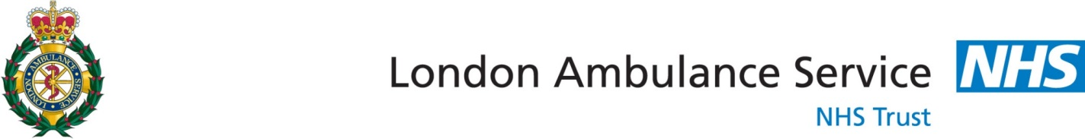
FOR DECISION
Executive Leadership Team

Date

From | Kevin Bate – Deputy Director of Operations
Subject | Bariatric Service Provision

- Background
The UK is currently recording some of the highest levels of obesity in Western Europe and these figures are only expected to increase steadily in the coming years ^{(1, 2, 3, 4)}. With obesity linked to numerous comorbidities and health problems there is a strong need for the London Ambulance Service NHS Trust (LAS) to be in a position to provide clinically effective and safe care to this patient group. The LAS has an operational process in place to cater for obese and bariatric patients, but in order to provide the level of service required in future years there needs to be a review of existing procedures, policies, clinical interventions, training, risk assessments and vehicle suitability.
In a recent inspection of the LAS by the Care Quality Commission (CQC) (2015) a number of actions were identified for the improvement of bariatric care provision. As a result of the CQC report the Quality Improvement Programme (QIP) was established to manage a series of work streams and local action logs within specific areas; bariatric activity is captured in work stream 3. Bariatric care by the LAS was also identified by Commissioners as a Commissioning for Quality and Innovation (CQUIN) goal which involves identifying and scoping areas for improvement within this specialist patient group. Provision of bariatric care was also being investigated by the LAS due to serious incidents involving this patient group and injuries to staff due to manual handling practices, resulting in increased levels of sickness in the Trust.
The Bariatric Working Group (BWG) was established by the LAS to review and analyse the available information on bariatric patients and develop scope for improvement. This includes making recommendations for future vehicles, equipment, training and operating models. The group was formed of members from all the LAS departments that are relevant to the progression of bariatric service provision, and included engagement from the patient’s forum through a nominated representative. A separate meeting was held to inform any other members of the patient’s forum who held an interest in bariatrics concerning the progress of the BWG and its aims; feedback from the attending members was noted and has been utilised to inform the decisions and suggestions of the BWG.
The group has responsibility for overseeing a preliminary research phase, where the medical directorate representative identified that the term ‘bariatric’ actually refers to a branch of medicine; although the term has colloquially and historically been used to describe obese patients, diluting the definition of what is included in bariatric care. There were also multiple definitions by various health agencies around the world; the World Health Organisation (WHO) only gives due consideration to body mass index (BMI), a measure of weight against height (kg/m²). This definition lacks real world application for an ambulance service. BMI doesn’t account for weight compared to shape; for example, having two patients of the same increased BMI but different shapes (one is obese and one has increased muscle mass) may mean that due to side wall positioning or trolley bed width the obese patient cannot be secured, issues not generally experienced by a muscular patient. BMI does not always correlate to mobility, extraction or comorbidities related to obesity; there would also be a higher incidence of inappropriate bariatric vehicle utilisation due to patients with high muscle mass being classified as ‘obese’.
The BWG determined that the pre-hospital definition of ‘bariatric’ for the LAS should include other relevant factors; David Whitmore (BWG clinical lead) recommends the following definition:
“Where the patient exceeds the safe working load and/or dimensions of standard LAS equipment used in normal day to day treatment, and/or where the weight, size, shape of the patient, in conjunction with the environment is such that non-standard equipment/treatment(s) may be required to provide access to/egress of the patient to a suitable treatment facility.”
By its nature, this definition will exclude most children, although consideration for clinical interventions in bariatric children will remain as part of the training. Equipment will therefore focus on the assessment, management, movement and transport of adult patients.
- Proposal
To improve the level of services provided to the bariatric patients
To improve specialist manual handling equipment availability through the provision of purpose designed bariatric capable resources distributed geographically across London.
To provide initial and refresher training to new and current operational staff on bariatric patient clinical care and manual handling considerations.
To provide enhanced training to specialist groups to support the provision of bariatric capable resources response
To develop a process for the accurate capturing of information relating to bariatric journeys and identifying potential bariatric requirements prior to contact with LAS.
- Discussion
Historically, bariatric capability was provided through the Patient Transport Service (PTS) however, due to the phasing out of PTS there are now no staff trained in the use of the bariatric equipment. Third party providers with bariatric capability are now the primary point of contact with the provision of 1 x 24 hour vehicle and 1 x 12 hour vehicle.
In current process, should a bariatric patient require emergency treatment, they will be visited by a frontline crew who will provide immediate support and lifesaving interventions. If specialist transport is needed, then an incident response officer (IRO) or clinical team leader (CTL) will visit the scene and approve the use of a bariatric vehicle, or contact the hazardous area response team (HART) to assist with the removal if there are factors that complicate extraction.
The bariatric capable vehicles however form part of the normal private ambulance service provision contracted to enable LAS to manage the significant levels of demand currently being experienced and means that these vehicles are frequently already deployed on other calls when a bariatric requirement is identified.
If none of these vehicles are available then the time frames in which they could attend the patient are compared against contracting other private bariatric services on an ‘as needed’ basis and the vehicle with the fastest estimated time of arrival is allocated to the call. This process is inefficient and causes further delays in providing assistance to bariatric patients.
As a result of a significant incident report, the current LAS system for providing bariatric transport was examined and tested. A series of random audits of bariatric service availability was conducted and reported to the Medical Director. The findings at the time the audits were undertaken were that there were either no vehicles available to send due to the single bariatric capable vehicle being already deployed on a normal incident as part of the private ambulance contract, or there were no appropriately trained PTS staff available to use the LAS bariatric vehicles.
With regards to recommendations relating to the scale of the bariatric capability that should be developed, access to bariatric patient information is limited, leading to potential complications in providing a clear set of actions that need to be undertaken in order to improve the service and assist with the continuation of high quality care. The LAS currently does not have a robust method to capture bariatric patient journeys and calls within the existing systems (e.g. command point), creating a misleading picture of bariatric patient numbers in London. There is also no current process of asking the patient’s weight whilst taking a call in EOC. One way of collecting data currently is via the use of a dedicated line in the EOC for healthcare professionals to call and book bariatric patient journeys, but this does not capture impromptu emergency transport and the CAD does not have a consistent method of recording such information.
During emergency patient assessment the logging of information is completed on patient report forms (PRFs) which are not clinically coded with a ‘bariatric’ term, thus making it difficult to audit.
The number of bariatric calls is also being quantified through how many times HART are required for a lift assist; yet this could just as easily be for a patient with a medium BMI who has become stuck and the crew on scene cannot extract them. Business intelligence (BI) has modelled our current data on bariatric patient journeys into the graphs below:

Graph 1: LAS A&E bariatric patient journeys for 2015/16 including PAS/VAS and in-house providers.

Due to the lack of robust LAS data there has been a need to use data acquired directly from Public Health England (PHE)^{(4, 5)}, which monitors self-reported incidences of obesity (defined as a BMI greater than 30kg/m²) throughout England, to try and define the potential service delivery requirements for bariatric services into the future. This data has been analysed and modelled by the LAS BI team. The graphs below clearly show an upward trend in obesity levels in England, with the joint model evidencing an increase of more than 11% of the population being classified as obese over the course of 20 years. The London specific data has also been separated from the England averages and then been directly compared to show trends and modelling for future growth (graph 3); whilst London does currently have lower levels of obesity than the England average, the modelling shows that it will continue on an upward trend. The modelled rate of obesity level increase for England (the capped England forecast) has been applied to London in order to predict the rate of growth.
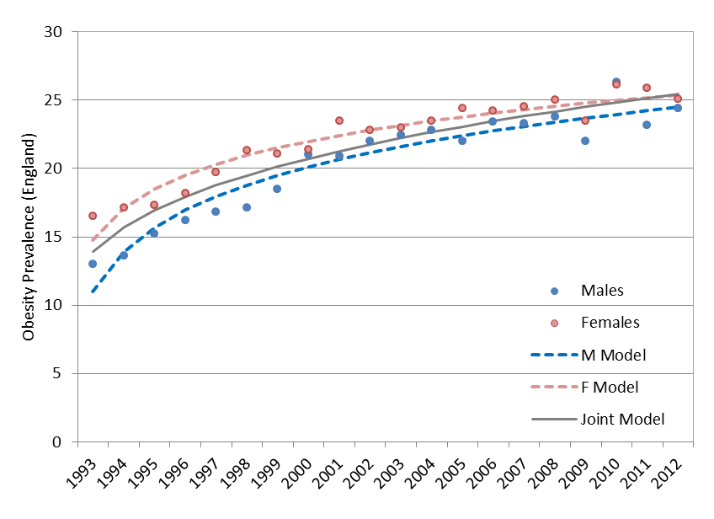
Graph 2: Historical trends of obesity in England 1993 – 2012.
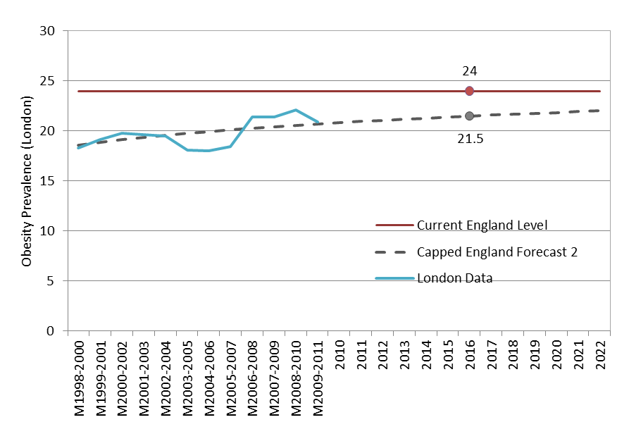
Graph 3: Modelling future obesity in London compared to current obesity levels in England.
As part of the scoping work of the BWG a visit to South East Coast Ambulance Service NHS Foundation Trust (SECAmb) was arranged to inspect their model of bariatric service delivery and compare elements of best practice. Whilst there were fundamental differences in their operating model that prevent total integration into the LAS, it was an ideal method to examine the equipment they have selected for use and get feedback from the clinical team leaders (CTLs) that use it. A bariatric away day was also organised for specialist providers of bariatric equipment, whereby they were given the opportunity to visit the LAS and provide further information about their products. The BWG attended on the day, with representatives from HART and NETS/PTS. During this session the suppliers showcased the use of their equipment in scenarios involving bariatric mannequins and confined spaces.
When refining the options for consideration, the BWG has discussed a number of methods of service delivery and explored a number of options relating to vehicles, staffing and equipment.
Limitations relating to the gross vehicle weight of vehicles means that the choice of vehicle poses specific difficulties in terms of combined weight of patient, crew and equipment potentially exceeding the plated weight for vehicle types currently in use within LAS. Multiple options are available to address this issue ranging from having multiple vehicles per bariatric unit (a patient carrying vehicle and an equipment carrying vehicle) or to increasing the size of the vehicle to a 7.5 tonne capacity. Each of these causes different difficulties in terms of cost, operational flexibility or user limitations and so it is likely that a bespoke system will need to be investigated and implemented in order to meet the specific operating requirements of LAS and will need further detailed investigative work following any approval for progression.
The staffing options also provide complexity in terms of how any vehicle should be operated. If all the workforce were to be trained in specialised bariatric equipment then it is probable that skills decay due to infrequency of use would continue to pose a risk to both staff and patients. Alternatively, the staffing of dedicated vehicles by specially trained staff ‘reserved’ for bariatric cases poses a significant financial burden on the Trust with potential activity being less than 1 case per day.
The equipment that has been recommended was trialled during the away day at Cody Road, and the combination of equipment approved (Appendix 1) was agreed by all members of the group that were present at the meeting. As a marked LAS vehicle that will be used for transporting unwell bariatric patients, it was deemed necessary for the vehicle to carry kit that matches the current profile for fast response units (FRUs); this was also in the event of the vehicle coming across a ‘running call’ and being able to provide assistance. The specialist equipment will be able to cater for patients that are up to 55 stone in weight; with limits of 35 stone for the EZ glide chair, larger patients can be extracted from upper floors using the evacuation mat. A vast majority of bariatric patients requiring journeys are below 55 stone, therefore this weight limit was selected; if this weight limit were increased, there would be a large upturn in expenditure and the equipment starts to become unwieldy in its use on a daily basis. The experiences of the SECAmb bariatric teams were that they had an exceptionally low number of patients that exceeded the weight limit of 55 stone, with the primary requirement for such specialist equipment relating to a person recorded as the heaviest man in the UK who had previously resided in Kent.

- Consultation
This proposal has been discussed internally as part of the work of the Bariatric Working Group. A briefing paper has also been provided to the Operations Board with support for development of an options paper for ELT consideration being received.

- Budget / Workforce Implications
As previously identified, the vehicle requirements need further investigation to ensure the most effective and efficient model is implemented should the decision to increase bariatric services be made. Based on indicative costings provided by Fleet department, the cost of a bariatric vehicle and specialised equipment would be in the region of £165,000 per vehicle.
The recommendation of the BWG is that LAS should have 3 such vehicles in order to provide adequate geographical distribution and availability.
The BWG has discussed several options with regards to staffing the ambulances:
- All NETS staff could be trained and therefore capable of operating the bariatric vehicles. This maximises the number of staff available at any given time that can operate the specialist asset and increases its resilience. They could be assigned as a double crew or as single responder on the vehicle. Using this setup, however, means that the staff would not be as experienced in bariatric care as a dedicated crew; there would still be a risk of skill decay. The specialist training would have to be provided and refreshed to a much larger pool of staff than if there were a smaller, dedicated team. Sourcing NETS staff would also remove six staff from other frontline duties at any given time, potentially reducing NETS capacity. Due to the nature of the bariatric vehicle size, further driving training would have to be provided to NETS staff to complete their C1 licence and blue light driving. NETS services would also need to be extended to 24/7 as opposed to the current model.
- All A&E staff could be trained and be redeployed onto the bariatric vehicle as it is needed however there are risks of skill decay and the timeframe for achieving training for all such staff would be significant.
- The ambulance is staffed 24/7 by a single crew member per shift. This operative would then take the vehicle to the bariatric call and provide specialist knowledge in extraction techniques and use of specialist equipment. The crew from scene would take clinical primacy and treat the patient whilst the operative drives the vehicle to the intended hospital / location. This provides specialist equipment on scene and a member of staff who is well versed in bariatric care. To staff a 24/7 service would need to be six people employed per vehicle (18 in total). As the nature of the job involves difficult manual handling, there is a higher risk of staff injury and illness. With such a small, specialist pool, there is a risk to resilience if any long term sickness occurs. There is an issue around whether there would be enough people on scene to initiate the extraction, but further frontline resources can be called upon to assist if necessary.
- A double crewed bariatric vehicle operating 24/7 with dedicated staff. Similar to the scenario above, but with the added advantage of having an additional specialist operative on scene to assist with lifting, extraction and problem solving. This would require 12 staff per vehicle, (36 in total). Other benefits include the option to have the original crew on scene (DCA) in the back of the bariatric vehicle, whilst one operative drives and the other takes the DCA vehicle to hospital so that both crews can become available immediately. This provides a much higher level of clinical care and would help improve JCT and prevent further OOS. The previously identified risks would be mitigated by having a double crewed bariatric service vehicle.
In options 3 & 4, as the clinical care for the patient could be provided by the initial responding A&E crew, the staff of the bariatric ambulance do not need to be Paramedics and instead would be manual tasking specialists operating specific vehicles and equipment to provide appropriate services to this patient group. It is possible that these staff would be graded in line with EAC staff at band 4.

The potential costs of a new service would therefore be

Vehicle and equipment £495,000 (7-10 year operating life)

Staffing (indicative Band 4 mid-point, 25% unsocial hours, outer London HCA and employers pension and NI contribution)

18 staff x £37,097 £667,746 per annum
or
36 staff £1,335,492 per annum

The cost of the current contracted service is approximately £919,800 per annum based on 36 hours provision per day. Increasing contracted services to 3 vehicles per day (should that be possible) would be £1,839,600 per annum.

There would be other costs associated with this service such as recruitment and training costs, end of shift overtime, management cost and estate cost which have not been factored into the above figures.

- Risks
The risks to the bariatric population as a result of transport delay has ready been identified in a number of SI reports. The level of services provided to bariatric patients has already been identified as a concern by the CQC and there is a CQUIN that currently relates to improving services to this patient group.
Likewise manual handling is still a significant cause of work related injury for ambulance staff and Datix information shows that there are a number of incidents whereby staff have injured themselves during the course of a bariatric call, usually related to the use of equipment or manual handling procedures.
The current reliance on external providers for such services does have a level of risk should those providers cease to operate or cease to provide that capability. Currently only one company provides this type of service with two other providers recently withdrawing from the market.
Alternatively, the provision of bariatric services over and above that which are currently provided will pose a financial burden on the Trust.
Another identified limitation is that of the lack of method for recording bariatric patient care and journeys in the existing system. Attempts at acquiring information from local authorities, social care services and other agencies around the location of known bariatric patients in London have provided no quantifiable results; therefore current discussions centre on the use of the current location alert register with frontline staff flagging addresses, adding information of interest (IOI) tags and writing pre-designated terms in the Command Point (CP) free text.

- Recommendations and Actions to Follow:
The recommendation of the BWG is to provide three specialist bariatric vehicles evenly distributed geographically across London.
Using three vehicles to provide a 24/7 service would keep travel times to bariatric calls at a minimum, which is key in providing care to these patients as extraction is usually a protracted event, already delaying definitive care for time critical conditions. In the event of one ambulance becoming unavailable for calls, the other two could cover the area and still provide a clinically safe service.
One issue that was identified during the inspection of LAS bariatric service provision was that the LAS PTS and external provider vehicles were being tasked to jobs outside of their bariatric remit, therefore when they were required to attend an urgent bariatric call they were unable to do so until they had become available from the previous call. This delay is unacceptable and has been related to serious incidents in the past. For this reason the BWG has suggested that the vehicles are targeted to bariatric calls and not made available for standard frontline calls; to maximise efficiency it was also suggested that the vehicles are multi-purpose for other low frequency calls; such as category 4 infectious diseases and can also be used to provide the specialist lifting equipment and techniques for patients who are not necessarily bariatric but who still pose issues in terms of extrication due to environment, location or size.
An additional benefit to the service of dual purposing these vehicles is that the existing frontline A&E ambulances used by HART for category 4 infectious disease transport can then be returned to standard frontline service. Bariatric calls also have a higher incidence of increased job cycle time, usually due to difficulties in extracting the patient from their environment. This increase in time spent with a single patient necessitates the need for more than a single vehicle, which would be prevented from assisting another bariatric patient for an extended period of time.
The staffing profile recommended by the BWG is for dedicated specially trained staff however there are a number of methods identified for achieving this. The significant cost associated with providing the service in this way is also recognised.
Clinical considerations for bariatric patients is also being built into the coming CSR programme to refresh staff in the complexities of this patient group and specifically relating to positioning and drug absorption, and will be included in the clinical induction program for all new staff.
Work is continuing in identifying the most effective method of recording bariatric patients both prior to them requiring LAS services and post LAS intervention to work on reducing the time taken to activate and provide specialist resources for the patient irrespective of if they are contracted or provided by LAS.

The Executive Leadership Team are asked to provide guidance on how the future development of bariatric services within LAS should be progressed. Subject to the decision of ELT, the Bariatric Working Group will be modified to focus on implementing any actions as required.

Prepared by:
Kevin Bate
DDO-Central Operations

References

- http://www.birmingham.ac.uk/research/activity/mds/centres/obesity/obesity-uk/index.aspx. Accessed 22/11/16

- http://www.nhs.uk/Livewell/loseweight/Pages/statistics-and-causes-of-the-obesity-epidemic-in-the-UK.aspx Accessed 22/11/16

- http://ec.europa.eu/eurostat/statistics-explained/index.php/Overweight_and_obesity_-_BMI_statistics. Accessed 22/11/16

- Health and Social Care Information Centre (2013). Statistics on Obesity, Physical Activity and Diet: England.

- Public Health England (2016). Public Health Outcomes Framework [Online]. http://www.phoutcomes.info/public-health-outcomes-framework#gid/1000049 Accessed 19/12/16

Appendix 1 – Suggested Bariatric Vehicle Equipment List
Medical equipment
Standard FRU kit;
LP15
Laerdal suction unit (LSU)
Primary response pack
LP1000 AED
Paramedic bag, complete (new Red bag type)
Resuscitation bag
Microvent Complete
Entonox administration kit, complete
LAS blankets - qty tbc
Burns pack
Infectious pack
Dressings pack
Maternity pack
Trauma pack
Cervical collars X 6 and bag.
*Personal Issue kit bag qty tbc
Red vehicle bag
Nonin 8500 Pulse Oximeter Complete
Vehicle fitted equipment
Oxygen system - qty2 x HX, piped, 2 outlets with dial up flow meters x 2
Masks & Airways - TBC
Re-chargeable torch - qty 2
Braun Alcohol hand sanitiser
LP15 Charger & Bracket
Laerdal suction unit
Latex free gloves - qty 4
Sharps box
Spare medical gas cylinders – qty tbc
Tissue box holder
Clinell wipes dispenser
Blue paper towel dispenser
Comms
MDT
Sat Nav
Airwave radio
Handportable radio - qty tbc
Patient handling kit | Weight Limit
Stretcher; Ferno Harrier LT LBS Stretcher c/w floor locks | 400kgs lowered, 350kgs raised
Additional cost for Track locks for above
Chair; Ferno EZ Glide power Traxx | 227kgs
Additional cost for Spare battery for item 4
Additional cost for Vehicle storage bracket for item 4
Additional cost for Detachable seat extender for item 4
HoverJack air patient lift 32" | 544kgs
Hovermatt 34" Double Coated | 544kgs
HT-Wedge (box of 1) | 360kgs
Air Supply
Single Patient Use Disposable Hovermatt | 272kgs
EMS EvacMat | 400kgs
Replacement board for EvacMat
Hoisting kit for EvacMat
Ladder Handles for EvacMat
Weather proof cover for EvacMat
Casualty Handling slings
Slide sheets Blue
Pro Move Bari kit
Managar Camel | 320kgs
Spare Airflo Plus compressor
Spare battery for Airflo Plus
Mains charger for Airflo Plus
12v charger & bracket for Airflo Plus
· Roller ramp | 453kgs
· Extension Cable

