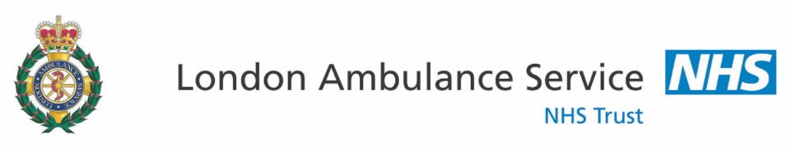

Paramedic Programme Patient and Public Involvement (PPI) Volunteers
ROLE DESCRIPTION

Background

The London Ambulance Service (LAS) Paramedic Programme recognises that patient and public involvement (PPI) brings an essential and independent component to the work of the paramedic programme. Being separate from the day-to-day running of the LAS, patients and public involvement has become an integral component in the development and shaping of the training programme and its outcomes.

The Paramedic Programme is run by the LAS and enables currently employed Emergency Medical Technicians (EMT) and Emergency Ambulance Crew (EAC) the opportunity to progress to Health and Care Professions Council (HCPC) registered Paramedic status.

The Paramedic Programme consists of an access ‘ramp’ module lasting six months, followed by three semesters of study, each lasting a further six months. The total time from engagement on the ‘ramp’ module to completing the semesters is two years. During this time, students must continue their clinical practice with Practice Placement Educators (PPEds).

The PPI programme is committed to equality, diversity and inclusion in all of its activities.

The Role of Paramedic Programme (PPI) Volunteers
This role description is intended to assist the PPI volunteers to play a key role in the development of the Paramedic Programme. Volunteers assist in the development of specific elements of the programme including: module development for specialised subjects; delivery of modules; acting roles as patients during observed student assessment, assessments during new intake of students and the monitoring of the PPI programme.

Where do PPI volunteers come from?

- LAS Trust members
- Healthwatch
- The Patients’ Forum for the London Ambulance Service
- Relevant and appropriate voluntary organisations

Frequency and duration of volunteer attendance

PPI volunteers will be invited to attend for Academy sessions based on their knowledge, skills and interests. They will engage at various different stages of the programme and frequency and duration will be agreed according to the engagement being undertaken and the volunteer’s time commitments.

Expenses

Travel expenses may be claimed on the submission of an Expense Claim Form, which will be provided on the day of attending.

??? £20 payment?

Accountability

- The Patient and Public Involvement Panel (PPIP) will invite lay participants to attend specified meetings of (PPIP) throughout the year.

- PPIP will monitor the effectiveness of volunteer engagement in the work of the Academy and will collect feedback from the volunteers.

Conflicts of Interest

All Conflict of Interest must be declared by volunteers, if the volunteer becomes aware of an interest, which could potentially harm the objectives of the Paramedic Programme, students, other volunteers or staff members.

Academy Staff

Paul Bates | Higher Education Manager  LAS Strategic Lead and Health and Care Professions Council (HCPC) named Lead for The HCPC Paramedic Programme.
Dominic Browne  and  Angela Hilliard | Programme Leads  Tactical leads and programme development for the HCPC Paramedic Programme.
Paul Johnson | Education Manager  Resource lead for the HCPC Paramedic Programme.
Module Leads | Individual module development and day-to-day delivery of the Academy HCPC Paramedic Programme.

Patients’ Forum for the LAS Members
Malcolm Alexander | Chair, Patients’ Forum for the LAS  -Healthwatch Hackney, Board Member.  -Healthwatch and Public Involvement Association, Chair.  -Former lecturer in patient and public involvement at  Westminster University.
Polly Healy | Member of the Patients’ Forum for the LAS  -Healthwatch Kingston, Member.  -Healthwatch and Public Involvement Association, Member.  -Sunbury Health Centre Patient and Public Involvement  Group Committee Member.  -Director/Secretary, Support and Advocacy for MS, CIC
Janet Marriott | -Sec. Greater London Forum  -Sec Richmond upon Thames Forum for Older  People  -Hounslow & Richmond Community Health PPI -Committee Member  -Healthwatch Richmond  -Patient's Experience Committee Member to 6 Hospitals:  West Middlesex, Chelsea & Westminster, Kingston, St  George's, Queen Mary's Roehampton, Teddington  Memorial.  -Trustee: Teddington Old People's Welfare Association (  Elleray Hall Community Care )  -Met Police Volunteer & Committee Member of SNB

Glossary of Terms Used in the Programme
CEPN | Community Education Providers Network
Cohort | Group of students
EAC | Emergency Ambulance Crew
EMT | Emergency Medical Technician
GSM | Group Station Manager
HCPC | Health and Care Professions Council
HW | Healthwatch
HWE | Healthwatch England
LAS | London Ambulance Service
LHW | Local Healthwatch
PEds | Placement Educators
PFLAS | Patients’ Forum, LAS
PPI | Patient and Public Involvement
PPIP | Patient and Public Involvement Panel
PRM | Programme Members
PM | Panel Members
RTP | Return to practise
SEMs | Student Enrolment Management Systems
ToR | Terms of Reference
QGMs | Quality Governance and Assurance Managers

Web Addresses

Health and Care Professions  Council | www.hcpc-uk.org
London Ambulance Service | www.londonambulance.nhs.uk
Patients’ Forum LAS | www.patientsforumlas.net

