The Care Provided by the London Ambulance Service to Patients in Sickle Cell Crisis

The London Ambulance Service NHS Trust (LAS) looked at the care provided to patients in sickle cell crisis in 2004 and 2011, which showed that improvements in care had been made. However, patient feedback suggested that more could be done for patients suffering a sickle cell crisis. As a result, we carried out another audit to assess the care we are delivering.Pleasingly, we found that improvements had been made in many areas but we are committed to continuing to improve the care we provide sickle cell patients:
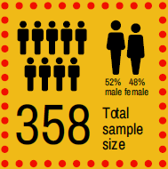
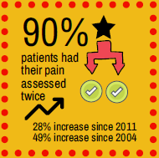
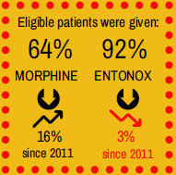
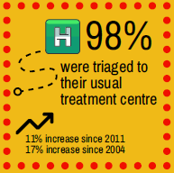
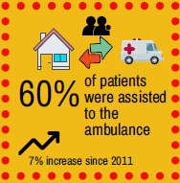
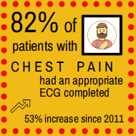

In order to understand patients’ experiences of the care they receive in sickle cell crisis, we sent a patient questionnaire to patients we attended for a crisis in April 2016. Thank you to those who responded, this was an invaluable part of the audit. Our questionnaire results were positive; with many stating that staff were friendly, engaging and helpful. However, some patients suggested they would like more information on the care they can expect from us.

Expected waiting times
We receive roughly 5,000 calls a day from all over London. To make sure patients in an immediately life-threatening condition are given the care they need as soon as possible, calls are categorised using an international triage system which categorises patients according to the symptoms described to the Call Handler during the999 call. If you are experiencing a sickle cell crisis which is identified as potentially immediately life-threatening you would require an emergency response similar to that for a patient suffering a heartattack – this response is within 8 minutes 75% of the time. Where there are no immediately life-threatening complications in your crisis, your call will be triaged to receive a response within 45 minutes (our audit shows that many patients receive a response well within 45 minutes).
What to say when you phone for an ambulance
We understand that when you are experiencing excruciating pain, it can be very difficult to communicate with our Emergency Call Handlers. If this does happen, key words you can say are ‘sickle’ ‘crisis’ and where your pain is, such as ‘legs’. That way we will know how best to triage your call. Please try to answer the questions asked by the Call Handler so we can get you the right help in the right time frame.

We found that one patient in our sample made their own way to hospital without cancelling the ambulance first. As the LAS is increasingly busy, patients should cancel an ambulance when it is no longer required to allow that resource to respond to another emergency call.

What our clinicians can do for you on scene
Different skill levels of clinicians may be on the ambulance or fast response car which attends you and this will determine what pain relief can be offered to you. If a Paramedic comes out to you, they can administer Entonox (gas and air), paracetamol/ibuprofen and/or morphine – if your treatment plan advises morphine. If you are attended by a non-Paramedic crew, they can administer Entonox and pain relief such as ibuprofen and paracetamol. Regardless of the clinician’s skill level, they will all work with you to reduce your level of pain on the way to hospital. It is really important you take your own medication and tell the LAS clinician what you have already taken.

The LAS crew will, wherever feasible, take you to your specialist treatment centre. However, if you are a long way from home, e.g. at a friend’s when you are taken ill, you will be taken to the nearest A&E. The LAS cannot travel long distances across London to take people to preferred hospitals as other patients who are waiting for ambulances require us to attend them. All A&E departments can treat sickle cell crises and you can be transferred later for on-going treatment if needed.

Giving us feedback
If you are not happy with the care you receive from the LAS on any occasion, please contact our Patient Experiences Department at ped@londonambulance.nhs.uk or on 020 3069 0240.
If you had a good experience with the LAS and want to complement our staff, please contact our Communications Department at staffrecognition@londonambulance.nhs.uk or on 020 7783 2123, or visit: http://www.londonambulance.nhs.uk/talking_with_us/thanking_our_staff.aspx.
Clinical Audit and Research Unit (CARU), London Ambulance Service NHS Trust

