**LAS Commissioning Weekly Update**

**30rd January 2015**

**LAS Performance**

|  |  |  |  |  |  |  |  |
| --- | --- | --- | --- | --- | --- | --- | --- |
|  | **Category A** | | | **Red 1** | | **Red 2** | |
| Week to date figures for 23/01/15 – 29/01/15 | Incidents | % reached in 8 mins | % reached in 19 mins | Incidents | % reached in 8 mins | Incidents | % reached in 8 mins |
|
| **LAS Total** | **8986** | **62.22%** | **92.71%** | **300** | **69.67%** | **8686** | **61.96%** |

LAS Cat A weekly performance is currently at **62.22%** and YTD performance at **60.06%** which is a slight drop on last week’s performance of **62.98%.**LAS continue to save ambulance attendances through the use of the Clinical Hub; for week ending 25th January the clinical hub achieved 2,938 dispositions without the need to deploy an ambulance response.

|  |
| --- |
|  |

Cat APerformance tail

The “Cat A performance tail” is monitored as an indicator of safety during periods of underperformance. Using the diagram below, LAS achievement against the 75% target is within10 minutes and 95% within 20 minutes (YTD). This represents a slight drop on last week’s performance (95% within 19 minutes).

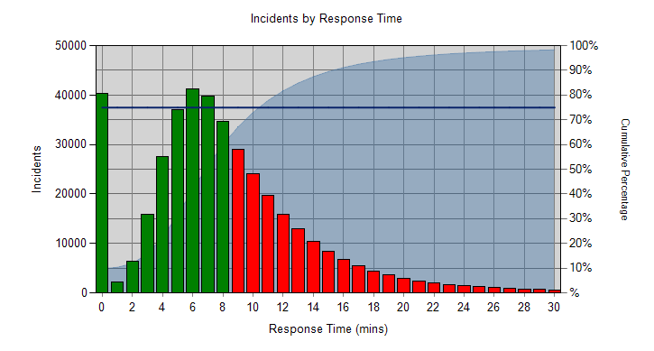

**LAS Updates & Reports**

Please see below the Weekly Exception Report provided by the LAS for week ending 25th January.

****

**LAS Transformation Survey**

Rob Larkman recently contacted all chief officers advising them of a survey that is being undertaken to help develop a sustainable transformation plan which will allow LAS to improve its performance, deal with changes in demand, and strengthen the system of emergency care support across London. The transformation plan will focus on operational improvements, performance management and organisational health initiatives as well as inform our contracting strategy. We want to ensure that our plan incorporates the points of view of all stakeholders, importantly including the CCGs.   
  
To gather your input we have designed a very short online survey. **It should only take around 5 minutes.** The objectives of this short survey is to:

·         Understand your local priorities with regards to LAS at a pan-London level and locally at a cluster / CCG level  
·         Get a sense of trade-offs you would be willing to make with regard to those priorities  
·         Understand what you would like to see in the transformation plan

Link to the survey: [https://www.surveymonkey.com/s/SR3Z39S](https://mail.westminster.nhs.uk/OWA/redir.aspx?C=cd38760fb3c14de6afc23af984fa08e5&URL=https%3a%2f%2fwww.surveymonkey.com%2fs%2fSR3Z39S" \t "_blank)  
  
**Please complete ASAP - Friday 6 Feb is the final deadline.**

This is an excellent opportunity to have your say on the future development of the ambulance service, and we would encourage all of our stakeholders to take part in this survey.

**LAS Invoices**

We have received a number of queries from CCGs regarding the invoices that they have received from LAS for items that were outside the normal SLA invoices. We can confirm that these invoices are acceptable to pay, and have outlined what these invoices relate to below

HART

HART, or Hazardous Area Response Team, is a specialist ambulance team that provide emergency response in crisis situations, such as a Buildiing Collapse, Chemical/Biological Incidents, or other mass casualty events, and are a crucial component of meeting the ambulance service obligations under the Civil Contingencies Act. HART has been part of the LAS contract for several years, however because it does not form part of the contract baseline it is invoiced seperately.

Adrenaline Research Trial

This relates to a research trial LAS are conducting in association with Warwick University. The proposal was discussed at the Clinical Quality Review Group held on 4th June 2014, and subsequently a formal proposal ffor funding to support participation in the trial was sent to Commissioners on 4th July. The response for the proposal was supportiive, and LAS proceeded on that basis. This funding was varied into the financial schedule, and revised invoices were raised for CCGs.

Intelligent Conveyancinng

The Intelligent Conveyance project has been in use across London to smooth arrivals to acute hospitals. The system began as a pilot, and following an independent analysis of the project, it was agreed to add an additional £1m would be added to the contract in order to fund the system to year end, at which point further discussions would be held on how best to take the system further.

**News and Statements from the LAS**

**Planned industrial action suspended**

Unison and GMB confirmed that the planned industrial action for 29th January was suspended. Please see the links below for further information:

<http://www.unison.org.uk/planned-nhs-strike-suspended>

<http://www.gmb.org.uk/newsroom/nhs-strike-suspended>

**Australian and NZ Paramedics starting work in London**

The 26th January saw the first day of work for some of the 175 paramedics who have been recruited to join the London Ambulance Service.

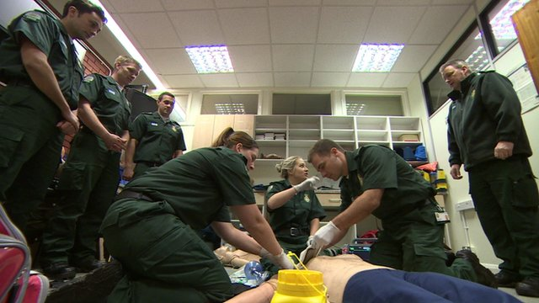

The number of paramedics leaving the profession in London has almost trebled in the last three years, and Jason Killens of London Ambulance Service says he cannot employ paramedics quickly enough from the UK's universities.

There is due to be another recruitment drive in Australia in September.

*Sources: London Ambulance Service and BBC News*

**Team Contacts**

|  |  |  |  |
| --- | --- | --- | --- |
|  |  |  |  |
| Elizabeth Ogunoye | Team Director | 0203 350 4219 | elizabeth.ogunoye@nw.london.nhs.uk |
| Katy Neal | Head of Performance | 0203 350 4229 | [katy.neal@nw.london.nhs.uk](mailto:katy.neal@nw.london.nhs.uk) |
| David Whale | LAS Contract Performance Manager | 0203 350 4053 | [david.whale@nw.london.nhs.uk](mailto:david.whale@nwlcsu.nhs.uk) |
| Julian Williams | Directory of Service Lead | 0203 350 4605 | [julian.williams@nw.london.nhs.uk](mailto:julian.williams@nwlcsu.nhs.uk) |
| Stephanie Grant | Product specialist 111 /OOH/UCC contracts | 0203 350 4171 | [stephanie.grant@nw.london.nhs.uk](mailto:stephanie.grant@nwlcsu.nhs.uk) |
| Mayarun Begum | Project Officer | 0203 350 4752 | [mayarun.begum@nw.london.nhs.uk](mailto:mayarun.begum@nwlcsu.nhs.uk) |
| William Sheppard | Team Administrator | 0203 350 4174 | [william.dunbar-sheppard@nw.london.nhs.uk](mailto:william.dunbar-sheppard@nw.london.nhs.uk%20) |
| Eleanor  Campbell | Administration Support Officer | 0203 350 4187 | [Eleanor.Campbell@nw.london.nhs.uk](mailto:Eleanor.Campbell@nw.london.nhs.uk) |
| Daniel  Gadd | Directory of Service Administration Support Officer | 0203 350 4401 | [Daniel.Gadd@nw.london.nhs.uk](mailto:Daniel.Gadd@nw.london.nhs.uk) |
| Lucy  Olliff | Directory of Service Administration Support Officer | 0203 350 4206 | [Lucy.Olliff@nw.london.nhs.uk](mailto:Lucy.Olliff@nw.london.nhs.uk) |