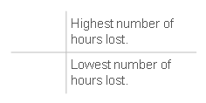

**EXECUTIVE SUMMARY**

**Ambulance Response Programme Hospital Conveyance**

This map shows the location of each ED hospital across London.

The size of the bubble relates to the comparative hours lost* at that hospital.

The larger the bubble, the more hours lost at hospital.

For example, during the reporting week, the highest hours lost were at Northwick Park.

The fewest hours were lost at Homerton, as the bubble can barely be seen

* Total time accrued after 15 minutes, for arrival at hospital to patient handover.

