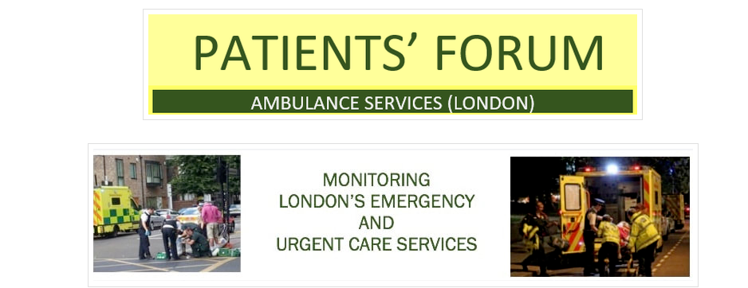
February 6th 2020
Dear Members,
I am writing to explain why we have not held Forum meetings recently and to provide you with information about current problems in our relationship with the LAS.
The Forum has had an outstanding relationship with the LAS since 2003. We have worked closely with hundreds of LAS staff at every level of the organisation, to promote better patient care. We have monitored LAS services and our members have given huge amounts of time to support the LAS prior to CQC inspections, monitoring EOC and 111 services, going on 12 hour ride-outs, participating in numerous LAS committees. We have also supported the development of the LAS Academy, by volunteering as mock patients and as scrutineers of the education system within LAS. We have held 100s of public meeting to which LAS staff were frequently invited to speak as part of our joint service improvement programme.
However, since May 2019, the attitude of the LAS has changed substantially. The LAS leadership have refused access to their Conference Room for our monthly meetings, refused to provide copies of documents, e.g. Board papers, stopped sending us monthly performance reports on targets and ambulance queuing, and tried to put pressure on the Forum regarding the content of our website. They have also told the Forum that our working relationshihps with colleagues across the LAS should stop and that all contacts should be through a single point of access email box. We did try to use that system, but the responses to our questions were frankly inadequate, and we cannot work with the LAS on service improvement – our major goal, if we can’t discuss patient care with clinical staff.
In addition, LAS responses to our reports on the 111, EOC and the complaint service have been stopped.
Thus, a major impasse in our relationship with the LAS has been reached and we need your views and ideas about the way forward.
We are seeking new places to meet, so that we can restart our monthly meetings and our programme of influencing urgent and emergency care services across London. New approaches will be needed, but we are confident and determined that the great public involvement work of the Patients’ Forum will continue and will thrive in order to meet the need of patients on the front line of emergency and urgent care.
Very best wishes

Malcolm Alexander
Chair,
Patients’ Forum – Ambulances Services - London
07817505193

