Krupesh Hirani AM
Chair of the London Assembly Health Committee
krupesh.hirani@london.gov.uk

8/3/23

Dear Hirani,

Thanks so much for your excellent letter of February 20th following the Health Committee’s review of the LAS and its developing strategy for 2023-2028.

We are very pleased that you have highlighted the issue of involving the patient voice in LAS decision-making. The LAS was in the past an outstanding organisation (until 2021) in relation to patient and public involvement and learning from their voice, and was commended by the CQC for their very effective public involvement work. But in our view it now performs very poorly in this area, despite our many attempts to draw the attention of the LAS to their duties under the NHS Constitution. As an example, the LAS have failed to attend any of our last 14 meetings which all concerned matters which should have been of major interest to the LAS. The list of those they failed to attend is shown below, as well as details of the outstanding speakers who made a major contribution to the work of the Patients’ Forum.

We are grateful to you for raising the issue of access to performance data. We are very concerned about the refusal of the LAS to provide the Patients’ Forum and Healthwatch with access to monthly performance data, and data detailing performance at a borough level – this data is very important from the patient safety and public health perspective. We did provide you with our detailed report on this issue which was produced by Patients’ Forum member James Guest. Until September 2021, the Patients’ Forum and Healthwatch received monthly performance data relating recent performance, whereas the current data is provided infrequently, only on the LAS website, is months old, difficult to interpret and lacks critical data and granularity.

Regarding the diversity of LAS staff it is of particular significance that data over a period of 20 years shows very low levels of diversity amongst front line paramedics. The percentage of front-line paramedics from a BME heritage has been slowly increasing, but recruitment from Australia may have impacted on the diversity of this group of staff.

We very much hope that the LAS recognises that in addition to having outstanding clinical staff on the front-line that it must also have: “high levels of engagement and that transparency should be the norm, in order to allow patients to constructively feed into decisions on how services are delivered.”

We also strongly believe it is essential that the LAS focuses on effective recruitment, retention and staff development.
Thank you for your scrutiny of the LAS and we hope to see the LAS reaching the high quality in engagement with patients and the public, which is the norm with other ambulance services across the UK and the NHS in general.

Very best wishes and thanks.
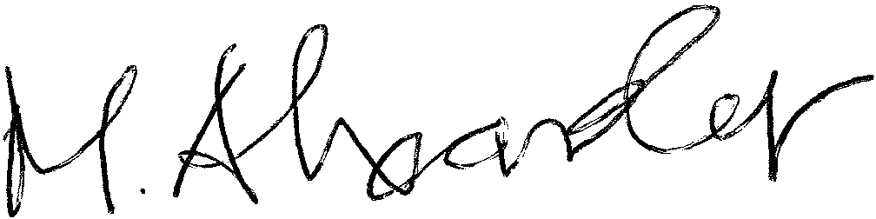

Malcolm Alexander
Chair
Patients’ Forum for the LAS
(& Healthwatch Hackney Board Member)
07817505193

James Guest FCA, MBA
Performance Data Lead
Patients’ Forum for the LAS

Meetings of the Patients Forum for the LAS, which the LAS failed to attend or contribute to:

2023

JANUARY 9th - LONG COVID - EXPLORING UNMET NEED –
AMINA ED-DEEN CoRe Service Hackney

FEBRUARY 21ST ADVANCING EPILEPSY CARE IN EMERGENCY MEDICINE
PROFESSOR LEY SANDER

2022

JANUARY 17th - PARITY OF ESTEEM IN MENTAL HEALTH CARE, 2021 – EQUALITY AND JUSTICE FOR ALL PATIENTS - SIR NORMAN LAMB – CHAIR OF SLAM

FEBRUARY 28th - PERFORMANCE OF AMBULANCE SERVICES ACROSS ENGLAND – MARK DOCHERTY - WEST MIDLAND AMBULANCE SERVICE
MARCH 21st - DEVASTATING WAITS IN EMERGENCY DEPARTMENTS –
DEREK PRENTICE – ROYAL COLLEGE OF EMERGENCY MEDICINE, &
CELEBRATING CHRIS HARTLEY-SHARPE - LAS FIRST RESPONDERS LEAD

APRIL 25th PARADOC - DOUG GREEN

MAY 23rd - BRIONY SLOPER – DEPUTY DIRECTOR HEALTH AND SOCIAL CARE IN THE COMMUNITY NHS LONDON REGION

JUNE 20th – THE IMPACT OF COVID ON SICKLE CELL DISORDER COMMUNITIES - JOHN JAMES, CHIEF EXECUTIVE, SICKLE CELL SOCIETY

JULY 18th –– THE QUEST FOR PATIENT SAFETY AND JUSTICE IN THE NHS - PETER WALSH, CHIEF EXECUTIVE, ACTION AGAINST MEDICAL ACCIDENTS

SEPTEMBER 21st – COVID ACTION CAMPAIGN - JOSEPH HEALY, FORMER PRESIDENT PFLAS

NOVEMBER 1st –- MENTAL HEALTH CRISIS IN CASUALTY - MARIE GABRIEL

2021

SEPTEMBER 6th - PREVENTING SUICIDE AND SELF-HARM - ALEXIS SMITH - PATIENTS’ FORUM LEAD ON PREVENTION OF SUICIDE AND SELF-HARM

OCTOBER 4th – OPTIMISING SYSTEM PERFORMANCE AND PERSONAL WELLBEING IN THE NHS: COURTNEY GRANT - PATIENTS’ FORUM LEAD ON STROKE AND HUMAN FACTORS

NOVEMBER 15th - NEZIAH'S MUM TALKS ABOUT THE DEATH OF HER BABY AND THE RESPONSIBILITY OF THE LAS TO LEARN FROM HIS DEATH

