UNCONCIOUS BIAS FACT SHEET
What is unconscious bias?
Psychologists tell us that our unconscious biases are simply our natural people preferences. Biologically we are hard-wired to prefer people who look like us, sound like us and share our interests. Social psychologists call this phenomenon "social categorisation‟ whereby we routinely and rapidly sort people into groups. This preference bypasses our normal, rational and logical thinking. We use these processes very effectively (we call it intuition) but the categories we use to sort people are not logical, modern or perhaps even legal. Put simply, our neurology takes us to the very brink of bias and poor decision making.
Just how hard -wired is unconscious bias?
Neuro-psychologists tell us it is built into the very structure of the brain's neurons. Our unconscious brain processes and sifts vast amounts of information looking for patterns (200,000 times more information than the conscious mind). When the unconscious brain sees two things occurring together (e.g. many male senior managers) it begins to expect them to be seen together and begins to wire them together neurally.
Brain imaging scans have demonstrated that when people are shown images of faces that differ to themselves, it activates an irrational prejudgment in the brain's alert system for danger; the amygdale. This happens in less than a tenth of a second. Our associations and biases are likely to be activated every time we encounter a group member, even if we consciously think that we reject a group stereotype.

The brain has a 'safety gateway' where these instincts can be shunted to the brain's social processing areas where our actions become empathetic. If this gating and shunting does not take place our instincts become behaviour.
When is unconscious bias most active?
We have very limited capacity in our brains to control bias. When we use up these resources bias is more likely to break through into our behaviour. When we are stressed, frustrated, angry or threatened these emotions overwhelm our resources and bias is left unfettered.
What are the differences in the levels of conscious and unconscious bias in society?
In the graph below, the red line represents the biases people will confidentially admit to. Almost no one will admit to having a prejudice against disabled people or women. However when unconscious biases are measured (the blue line) nearly 40% of people have unconscious biases against particular genders and black people, This massive discrepancy between our conscious and unconscious biases is the opportunity we have to improve our people decisions, and lever the advantages of talent for the benefit of our organisaitons
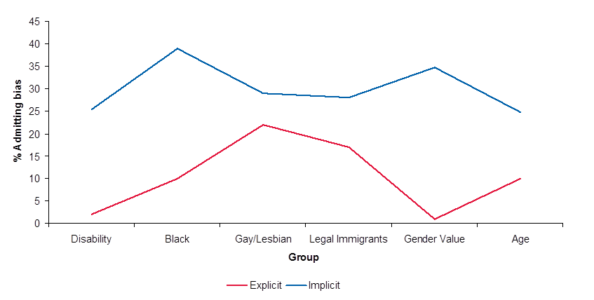

How does unconscious bias affect our behaviour?
Unconscious bias operates at a very subtle level, below our awareness. It results in almost unnoticeable behaviours (micro behaviours) such as paying a little less attention to what the other person says, addressing them less warmly or talking less to them. We tend to be less empathetic towards people who are not like us. These behaviours are small and not likely to lead to censure, but long-term exposure is corrosive.
What can I do about my unconscious biases?

We have a bias control mechanism in the brain that prevents our biases becoming behaviour. To trigger this mechanism our brain needs to see a mis-match between our wider goals (e.g. our desire to be or to be seen as fair, or not to get fired) and our instinctive people preferences. Having a personal goal that is fair, whether that is a moral position or because it makes sense for the business helps trigger our natural bias defences.

Being aware of what biases we have and how strong they are equips us to better manage our unconscious biases because we know which groups may trigger our unconscious categories and when we may need to be more vigilant.

Managing unconscious bias is not just of benefit to others. If we can control and manage our unconscious biases it releases cognitive and emotional resources. These resources lead to better/fairer decision making and enhanced problem solving, increased ability to think in novel situations, better logical reasoning and more persistence.

We can help people manage their biases by not exasperating the conditions under which biases are most active in our behaviour. Demands on behaviour can create anxiety about saying or doing the wrong things. Sometimes well intentioned policy places additional burden on the limited resources required to regulate bias, leading to the very effect we wanted to avoid.
The other thing organisations can do is to help people create their own bias control trigger. If organisations create the right atmosphere where fairness is linked directly or indirectly to the organisation’s goals, it can create the right conditions for a mis-match which can trigger the individual’s bias controls.

What action should I take?

For your institution:

- Consider where unconscious bias could have an impact in your institution, for example in recruitment and promotion decisions, line management and performance appraisals, student admissions, student assessment
- Consider training for your staff on what unconscious bias is and the impact it can have on their decision making as a starting point. In a time of reduced resources it is important that the decisions we make are sound and rational to ensure the best outcome, for example in recruitment and selection
- Consider processes that could be reviewed and mechanisms that could be introduced to ensure that the impact of unconscious biases are minimised and mitigated as far as possible

For you:
- Consider getting tested (www.implicitly.co.uk ) to identify the types and strengths of your unconscious biases. This can enable you to avoid making unchallenged decisions about groups for whom you know you have negative associations. This should be done in context; the tests Implicitly is the only test where the extent of of bias has been related to the likelihood of it resulting in discriminatory behaviour. Test takers are not given their feedback directly, but by a qualified coach. There are free test available on the internet, but these tests only measure the actual bias and not the way people act. A person’s test may indicate a bias that has never affected their actual behaviour. It can be difficult to complete the tests and receive the feedback without any support in interpreting the findings, and so the tests should be approached with some caution.
- Know where you are in terms of your motivation to change or manage your biases. It is unrealistic to expect to change deeply held beliefs, it may be all you can expect to manage them in key situations (e.g. appraisals, bonus awards, interviews, budget allocations)
- Our natural bias control mechanism needs energy to maintain its guard. Making sure we are supplying our brain with energy (sugar) at key times can help us maintain our defences. Taking breaks during extended or emotional discussions can help.
- Remind yourself of the need to be fair and objective at key times , either in your head or with written reminders such as posters and cards
- Recognise that when we are majority or dominant group members working with minority or non-dominant groups members that our performance may be impacted by this inter-group anxiety.

For further information please contact:

Tinu Cornish (tinu@coachforchange.co.uk) Dr Pete Jones (pete@shirepro.co.uk)

