MINUTES of the PATIENTS’ FORUM
MONDAY JULY 8th, 2019
LAS, 220 WATERLOO ROAD, SE1
ATTENDANCE: FORUM MEMBERS AND ASSOCIATES
Adrian Dodd – Waltham Forest
Anthony John – Tower Hamlets
Arthur Muwonge – Croydon
Audrey Lucas – Enfield Healthwatch – Executive Committee Member
Colin Hill – Berkshire
David Payne – Southwark
Graeme Crawford – Ealing
Inez Taylor – Southwark
John Larkin- Company Secretary – Barnet
Louisa Roberts – Tower Hamlets
Lynn Strother – City of London Healthwatch – Executive Committee Member
Malcolm Alexander – Chair, Patients’ Forum – Hackney Healthwatch
Mary Leung – Harrow
Mike Roberts - Hampshire
Natalie Teich – Islington Healthwatch - Forum representative to CARU
Sean Hamilton - Greenwich
Sister Josephine Udine – Chislehurst – Healthwatch - Vice Chair
Vic Hamilton - Greenwich

London Ambulance Service:
Briony Sloper: Speaker - Healthy London Partnership
Melissa Berry – Equality Consultant
Tracy Watts -
Athar Khan - Head of Performance

APOLOGIES:
Angela Cross-Durrant – Kingston – Vice Chair
Archie Drake – Hackney and Canada
Barry Hills – Kent
Beulah Mary East – Hillingdon Healthwatch - Executive Committee Member
Carol Bassi – Tower Hamlets
Catherine Gustaffe – Southwark
Cllr Dora Dixon - Fyle – Southwark
Elaina Arkeooll – Hammersmith and Fulham
James Guest – Ealing
Jan Marriott – Richmond
Jos Bell – Brockley (Socialist Health Association)
Joseph Healy – Southwark – President of the Forum
Philip Ward - Hammersmith
Rashid Ali Laher – Healthwatch Kingston

- Minutes of the meeting held on June 10th 2019 agreed a correct record.

- Matters Arising – also see action log

  - Inverse Care Law and Demand on the LAS
Agreed to collect information on the possible impact of deprivation on emergency ambulance response times in ARP Categories 1,2,3,4
Action 1: obtain data regarding pressure on ARP Cat 1-4 from Athar Khan and the opinion of public health experts on the association between deprivation and ambulance response times.
Action 2: Ask PHE for a link with their lead on deprivation and emergency care.
2.2 Diesel Engines and MDT screens
The Forum raised a number of questions in June 2019 about ambulance crew
having to leave diesel engines running to connect to MDT (communications with
EOC). The Forum were told by Julie Parham for the LAS that:

"Fuel and turning-off engines are something we would like to do, but the MDT is
reliant on a power source, therefore, for the time being we have to keep the
engines idling, in the near future we are looking at a new MDT that can operate
without needing the vehicle to remain idling".

We asked further questions as follows but have received no response:
- Will ambulances will be fitted with batteries to deal with this problem re power
sources for MDTs?
- In relation to the more general problem of air quality in London, traffic jams and
leaving engines on to keep the MDTs live, we wondered if there has been an
assessment of the health impact on LAS front line staff, e.g. asthma or lung
fibrosis?
- Is there guidance for staff encouraging them to turn off engines when they are
on down time?
Action: In view of difficulty in obtaining answers to these questions, raise with Trisha Bain and the Quality Oversight Group, Edmund Jacobs, Health and Safety and Justin Wand, Fleet and Logistics.
- Noted that the LAS capital budget has been cut by the government and this is affecting the purchase of new ambulance fleet.
Action: Raise with NHSI and STP.

2.3 Access to Prisons for Paramedics
The Forum will meet staff from the Ministry of Justice to discuss improved
access arrangements for paramedics who are called to emergencies in
prisons. This follows a positive response to our letter to Justice Minister,
Robert Buckland. Discussions have also taken place with Lyn Sugg from EOC
regarding the collection of data by the LAS when front line staff provide
emergency care in prisons. Lyn has agreed to start the collection of this data.

2.4 End of Life Care
Noted that the importance of showing regard to the culture and religion of
people receiving end of life care has been raised by Angela Cross Durrant with
the EoLSG. The issue has been prioritised by the end of life care steering
group and training has been provided to team members.

2.5 Emergency Supply of Medicines Post-Brexit
Action: Request report on the risks associated with Brexit in relation to drug
supply for the LAS, and the risk register for individual drugs in relation to
Brexit. Request made to LAS pharmacist.

2.6 London Bridge Inquest
Agreed to contact Chief Coroner to request information on Preventing Future
Deaths notices issued in relation to the London Bridge Inquest.
chiefcoronersoffice@judiciary.uk. The website for the London Bridge Inquest
(where court transcripts are published) is at:
https://londonbridgeinquests.independent.gov.uk/hearing-transcripts/
2.7 Complaints to LAS by Phone – agreed it is essential that complainants who
submit their complaints by phone receive a live recording of the telephone
conversation. Action: Refer to Trisha Bain

2.8 Equality and Diversity in the LAS
a) Melissa Berry reported that a new equality and diversity strategy was being
developed by the LAS and that the ambition for the LAS was to increase the
BAME percentage of staff from the current 15%, by 2.5% each year until
2028.She also reported on the development of the London WRES programme.

b) Noted that the percentage of BAME paramedics in the LAS remains at 7.5%
and that the intake of BAME paramedics to UK universities is 7% average and
8% in London. Melissa is working with universities to encourage them to take
positive action to increase the percentage of BAME entrants onto paramedic
science courses. She explained that the main sources of paramedics for the
LAS are either UK universities or Australia, with a smaller number coming
through LAS courses for TEACs. The percentage of BAME paramedics in
Australia is about the same as the UK.
Year | Percentage  BAME  Paramedics | Percentage  BAME Paramedics with Direct Patient Contact
2016-17 | 7.0% | 4.2
2017-18 | 6.4% | 3.9
2018-19 | 7.5% | 4.8

c) The LAS intends to introduce a cadet scheme to encourage future
recruitment to the LAS by promoting paramedic science courses and are
promoting a youth ambassador programme to encourage participation of young
people in the work of the LAS.

d) Audrey Lucas expressed concern that the situation regarding employment of
paramedics from a BAME heritage was stagnating, and accountability for this
situation should be placed at the door of the Secretary of State for Health and
Social Care.

e) Malcolm reported that he had an excellent meeting with Averil Lynch the
head of LAS recruitment and had written to the Chief Executive, Garrett Emmerson with a number of recommendations, but he had neither acknowledged nor responded to the recommendations – despite several reminders (report on meeting with Averil and letter to Garrett attached). The recommendations were as follows:

- To change the name of Emergency Ambulance Crew to Emergency Ambulance Practitioners. The word ‘crew’ has no positive connotations for this important profession.
- Ensure resources are available to fully cover the costs C1 training and licenses, without the trainee paramedic having to take out a loan.

- Publicise the very positive career trajectory for paramedics, compared to other professions, e.g. nursing. It is much easier for a paramedic to move from band 5 to 6, and there are now a wide range of job opportunities available for paramedics.

- Provide resources to expand Avril Lynch’s recruitment team, so that they can actively and continuously promote the profession of paramedic science in Further Education Colleges, Sixth Form Colleges and school six forms across London. Boroughs like Newham, Tower Hamlets, Brent, Southwark, Lewisham, Lambeth and Hackney would be excellent places to start. A target should be to work with at least 20 schools and colleges each year. A highly specialised recruitment team would be needed for this development – but it is essential and will ensure that the diversity of the paramedic workforce will within a few years remove the need to recruit from Australia.

- Develop recruitment campaigns in the boroughs highlighted above in churches, mosques and temples. Some of these places of religious worship have very diverse congregations of many hundreds of people who regularly attend services.

3.0 BRIONY SLOPER - Healthy London Partnership - Urgent & Emergency Care
IMPROVING CARE & OUTCOMES FOR PATIENTS

Slides available at: www.patientsforumlas.net/meeting-papers-2019.html

3.1 Briony described the Healthy London Partnership programme for improving
urgent and emergency care for London. The key elements are:

a) Alternative Care Pathways to avoid transfers to A&E, which includes the
involvement of the 111 service and a focus on care homes, rapid response teams
and the use of ‘flags’ for vulnerable patients, e.g. those with mental health
problems, or those who are at risk of falls and who may be frail. CmC is a key
resource for these patients.

Same Day Emergency Care (SDEC) which focusses on the development of
standardised pathways, reducing complexity in accessing services, further
developing systems for direct access for patients with high risk conditions, e.g.
stroke and the development of an acute frailty service.

Athar Khan described current problems with access to ACPs across London,
which includes a wide variety of different commissioning arrangements, variable
governance, paucity of data, little information about levels activity, a need for
enhanced training and a focus on collaborative working between ACP providers
and the LAS.

b) Enhanced Services in Care Homes (EHCH). This includes the training of
support care home staff to identify when patients are deteriorating and the
provision of additional primary care and community services support. The end of
life pathway includes an “expected death pathways’. Care homes are being
closely studied and data collected to understand how best to meet the needs of
patients and reduce the need for emergency ambulances. They are high users of
services and are likely to be under greater pressure if care staff leave as a result
of Brexit.

For frequent service users, the intention is to identify more supportive
and effective models and approaches in working with these patients and
assessing their impact.

3.2 Avoiding admissions –111 Star Lines - supporting LAS, care homes and
community teams to keep residents in their home with access to clinical advice
and alternative care pathways to avoid admissions. This includes developments
of the 111/IUC to provide better access to clinicians:

To enable community clinical staff to connect quickly with a clinician in the NHS
111 centre the following system is being developed:
  - 111 press *5 for LAS crews attending incidents at patient’s homes or care homes.
  - 111 press *6 for care home staff who require urgent clinical advice and support.
  - 111 press *7 for Rapid Response community nursing teams and domiciliary care workers.

These calls are routed to a NHS 111 call handler, who takes the patient details
and transfers the call to a clinician - if the clinicians are already on a call there is a
guaranteed call back within 20 minutes. The role of call handlers and clinicians
very considerably between different 111 services.

3.3 Rapid Response Services – designed to map, develop and pilot pathways for
direct access to rapid response rapid response services, including falls services
and services for patients with catheter problems. These services have been placed
in the Directory of Services (DoS) and are expected to provide a response with two
hours, but this target is not often met. Evidence from across north east London
shows that these services get few referrals from 111 and 999. Funding is a key
issue to secure the stability of this service.

3.4 Sister Josephine asked how social care will be built into the core of these
developing services. Briony said that social care will be built into the rapid response
services.

3.5 Audrey Lucas asked how these services would serve the needs of people with
learning disabilities, and how information would be provided across the system to
ensure that clinicians know where to access the care that patients need. Briony
said that the developing services were not yet focussed on the needs of patients
with learning disabilities.

3.6 Current Problems with Services

a) Briony described problems in the current falls’ services across London, where 70
services are listed as being available, but in practice only 5 services are available
for urgent referral. She described situations where patients may be visited by a falls
team, that does not have the capacity to lift patients from the floor, and therefore
leaves the patient on the floor until an ambulance arrived.

In response to a question from Audrey Lucas regarding 999 direct referrals to falls
Team, Briony said that there are many fall teams but few are able to respond rapidly
by providing assistance at scene.

b) Not all clinicians are examining patients ‘special notes’ e.g. CmC. Many LAS front
line staff are not currently using IPADS to access information from CmC.

c) Alternative care pathways across London have different opening and closing
times.

d) There is no guaranteed response within 2 hours.

3.7 Same Day Emergency Care - SDEC (ambulatory care)
https://improvement.nhs.uk/documents/2983/SDEC_guide.pdf
Briony said that SDEC refers to the investigation, care and treatment, within 2 day, of patients for whom admission to hospital would have been the default option in the absence of an SDEC service. It may also include patients who have had a brief overnight stay and are discharged through SDEC the next day, as well as patients followed up in SDEC after ‘early supported’ discharge. Effective SDEC depends on high quality local community services, which are in practice often not available, and provision of these service, wherever possible within 2 day of presentation. The national target includes patients experiencing ‘frailty’. Frail patients are assessed to ensure their safety and referred to a Frailty Team if meet the threshold. The complexity of Frailty means that patients with the same condition may be treated totally differently. There is also a danger of early discharge from hospital.
DEFINITION OF FRAILTY
People with frailty often have non-specific signs and symptoms, such as delirium, reduced mobility and a history of falling. It relates to the underlying processes emerging across several body systems simultaneously and to communication challenges. Both the underlying medical conditions and the presenting syndrome need attention. Frail patients with acute care needs are especially vulnerable to harm from delays in diagnosis. A patient whose delirium is not identified may not be very mobile or drink enough and the ensuing dehydration and pressure sores will add to the complexity of their care and chance of a poor outcome.
https://improvement.nhs.uk/documents/2984/SDEC_guide_frailty_May_2019_update.pdf

3.8 Targets for development of the SDEC and Acute Frailty Service
- By March 2019 - 75% to deliver same day emergency care services for at least 12 hours a day, 7 days a week
75% to deliver a frailty service (70 hours a week)
- Sept 2019 - 100% to deliver same day emergency care services for at least 12 hours a day, 7 days a week
- Dec 2019 - 100% to deliver a frailty service (70 hours a week)
- March 2020 - 100% to aim to deliver 30% of non-elective admissions via SDEC

3.9 Rising levels of admission to A&E and decline in GP consultation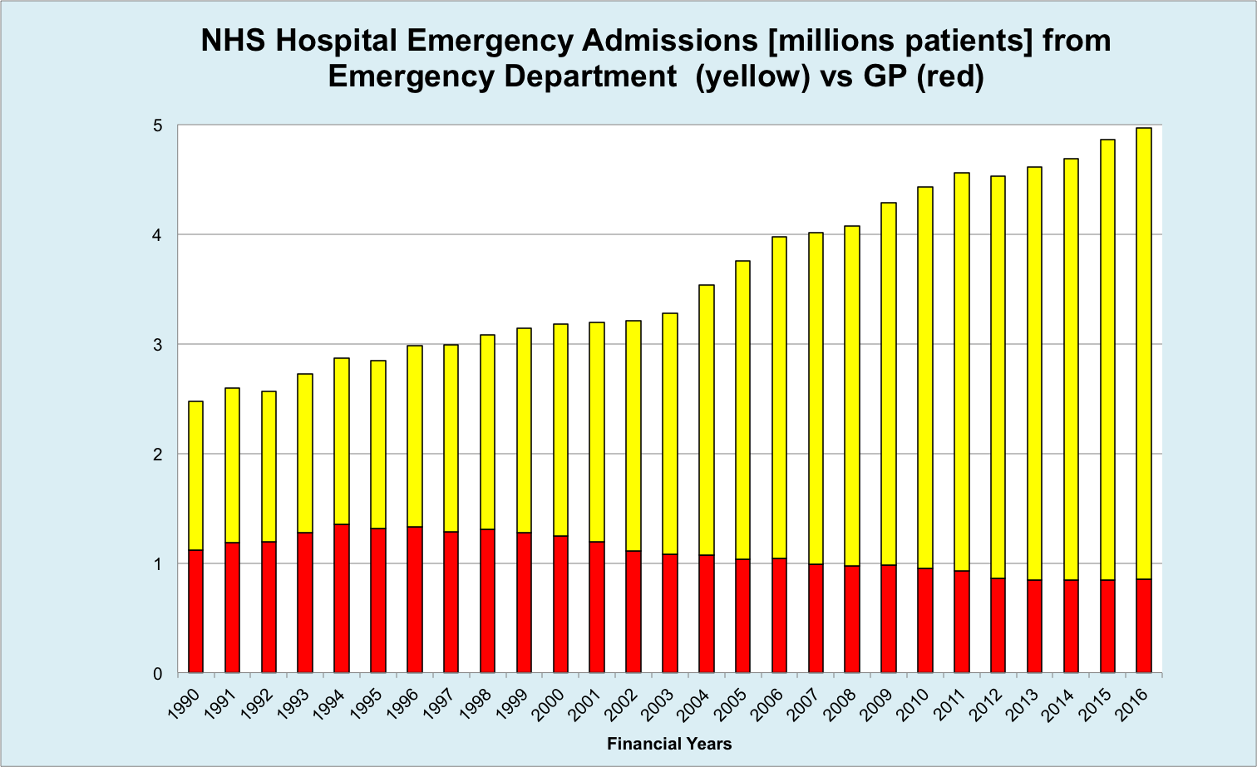

Briony said that average waiting times for admission to A&E are increasing. NHSE wants to abolish the four hours A&E target. SDEC is intended to reverse the rising levels of admission to A&E. Under the NHSE Long Term Plan, every acute hospital with a type 1 A&E department will move to a ‘comprehensive’ model of Same Day Emergency Care. This is intended to increase the proportion of acute admissions discharged on the day of attendance from a fifth to a third
Type 1 A&E department = Consultant led 24-hour service with full resuscitation facilities and designated accommodation for the reception of accident and emergency patients
3.10 A number of priority SDEC pathways have been developed for all Trusts to deliver and this requires senior clinicians to be present on the front line of A&E. Chelsea and Westminster Hospital is a leader in this development.
- Acute Kidney Injury (AKI)
- Atrial fibrillation
- Cellulitis
- Chest pain (low risk)
- Community acquired pneumonia
- DVT
- Falls (no injury)
- Hyperemesis
- Paediatric Asthma
- Pulmonary emboli (PE)
- Pyelonephritis
- Right upper quadrant pain or abscess
3.11 Care Homes - Development work in care home includes a campaign to decrease sickness of residents using flu vaccination, the input of pharmacists to enhance the effective use of medication, recognising deteriorating patients, a focus on higher quality end of life care and stronger links between care homes and alternative care pathways. Other development areas include:

Enhanced Primary Care Support
• Access to consistent, named GP and wider primary care services
• Hydration and nutrition support
• Access to out of hours/urgent care

Multidisciplinary advice and support including health and social care
• Expert advice and support for those with the most complex needs
• Helping professionals, carers and those with support needs to navigate

Reablement and rehabilitation
• Aligned rehabilitation and reablement services
• Developing community assets to support resilience and independence

Higher quality dementia care

Workforce Development
• Training and development for care staff
• Joint workforce planning
• Vaccination of staff

Data, IT and technology
• Linked health and social care data sets
• Access to the care record and secure email

End of life
• ‘What’s Best for Lily’ video is used for training in end of life care.
• Need for verification of deaths over the weekend when medical staff are not
available – creating and inappropriate police and crime scene.

The Significant 7 scheme has been designed by the North East London Foundation Trust (NELFT) and BHR CCG teams to help care home staff identify deteriorating residents, improve communications within the home and take appropriate action to meet each resident’s needs.
www.healthylondon.org/wp-content/uploads/2019/05/Significant-7-train-the-trainer-Guidance-for-Commissioners.-Jan-Mar2019.pdf

3.12 Frequent Callers are now called ‘high intensity users. There are many schemes designed to reduce the impact of frequent callers in south east London. The frequent caller teams are determining what models work best.

3.13 Briony Sloper was thanked for her outstanding presentation.

4.0 CQC Inspection – Noted that the CQC are currently inspecting the LAS and that the Forum has submitted a report to the CQC and met with the lead inspector.

5.0 Alcohol intoxication - response by the LAS
Noted that the report on the Soho project is not available from the LAS. Agreed to ask Fionna Moore if she has a copy.

End

