The 2017 ANNUAL GENERAL MEETING of the Company was held at the London Ambulance Service Headquarters, 220 Waterloo Road, London SE1 8SD on Monday 13 November 2017 at 7.00 p.m.
Minutes of the AGM
John Larkin the Company Secretary opened the meeting. He said that it was the 11th Anniversary of the incorporation of the Company.
- It was proposed by John Larkin and Seconded by Joseph Healy that the Report and Financial Statement of the Company for the year ended 31 December 2016 be received and adopted by the meeting. This was agreed unanimously.

- It was proposed by Malcolm Alexander and Seconded by Audrey Lucas, and it was resolved unanimously, that Sister Josephine Mary Udie, as a Director retiring by rotation in accordance with the Company's Articles of Association, and being eligible for re-election, be and is hereby re-elected as a Director of the Company.

- It was proposed by Michael English and Seconded by Dave Payne that Belinda Moira Strother, as a Director retiring by rotation in accordance with the Company's Articles of Association, and being eligible for re-election, be and is hereby re-elected as a Director of the Company.

- AOB – There were no items under AOB.

Dated this 13th day of November 2017
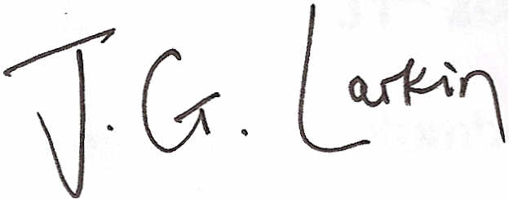
John Larkin
Director and Company Secretary

