NOTICE is hereby given that the 2017 ANNUAL GENERAL MEETING of the Company PATIENTS' FORUM AMBULANCE SERVICES (LONDON) LIMITED will be held at the London Ambulance Service Headquarters, 220 Waterloo Road, London SE1 8SD on Monday 13 November 2017 at 7.00 p.m.

AGE N D A

1. To be RESOLVED That the Report and Financial Statement of the Company
for the year ended 31 December 2016 be and are hereby received and
adopted by the meeting.
2. To be RESOLVED That Directors retiring
by rotation in accordance with the Company's Articles of Association,
be and is hereby re-elected as Directors of the Company.

4. AOB

Dated this 1st day of October 2017
BY ORDER OF THE BOARD
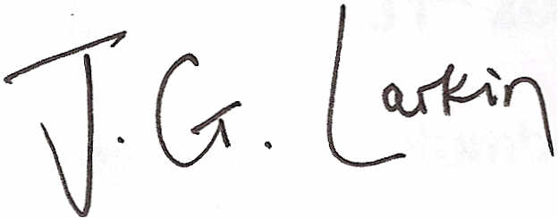
John Larkin
Director and Company Secretary

Note: This notice is issued more than one month before the meeting date
having regard to the need for compliance with the minimum 21-day period of
notice required to hold an annual general meeting of the company.

