PPI and Public Education update
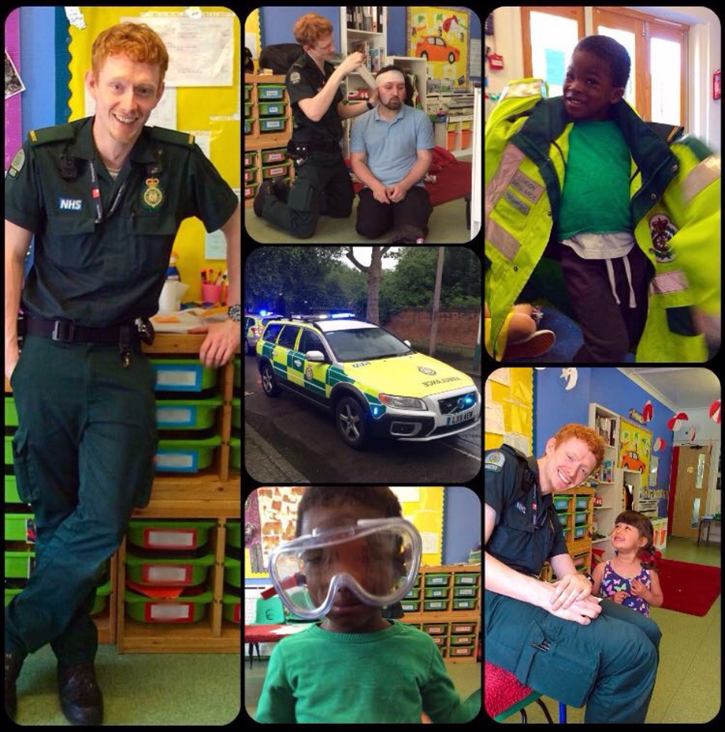

Some statistics from 2016:
- Visits/events that the LAS were invited to attend = 811
- Visits/events attended = 583
- Staff who were active in public engagement = 236
During the period of January/February/March 2017, we have had 185 event requests on our event database. Of these, we have attended 146. The types of events we attended were:
BLS and cardiac awareness Drugs awareness
Deaf awareness First aid badges (Brownies, Cubs etc)
Knife crime awareness People who help us/Jobs on the move/Superheroes
Road safety initiatives Older people, e.g. pensioners' groups
Learning disabilities Mental health
Junior Citizen Careers
Staff attend events and often to this in their own time. We currently have 1,084 members of staff on our interested staff list and since January 2017, 129 staff have been actively involved in public education.

Insight Project
Five Focus Groups were held between December 2016 and January 2017. Each group was independently facilitated and attended by patients, carers and LAS staff. Each meeting followed a slightly different approach, depending on the group and the issues raised.
A number of themes were identified from the Focus Group discussions, along with suggested improvements. These mainly relate to communication, responses to patients, access to services and information, care and treatment, and stigma. Findings are currently being written into a report, and changes will be agreed and actioned in the coming year.
RNIB
Following a suggestion from a member of staff, who was met with suspicion when he tried to help a blind person whilst in a public place, RNIB (the Royal National Institute for Blind people) was commissioned to undertake a patient survey. The survey focused on blind and partially-sighted people’s experiences of using ambulance services, and then more generally on the factors which affected their level of trust in strangers.
The survey found that most people who had had experience of using the ambulance service had a ‘very good’ or ‘good’ experience, in terms of the way staff behaved towards them.
Public Education Staff Development Programme - October 2016
Ten members of staff completed the Public Education Staff Development Programme. This programme offers staff the opportunity to develop the skills, knowledge and self-awareness that will help them when they are carrying out public engagement work.
Friends and Family Test
The patient Friends and Family Test (not to be confused with the staff Friends and Family Test) is still on going as a national requirement for all NHS Trusts.
We are only asked to report the results to NHS England from see & treat patients, and patients who use the Patient Transport Service (PTS).
Leaflets have been distributed to ambulance stations for staff to take out with them, and leave with any see & treat patients.

