NOTICE is hereby given that the 2019 ANNUAL GENERAL MEETING of the Company PATIENTS' FORUM AMBULANCE SERVICES (LONDON) LIMITED will be held at the London Ambulance Service Headquarters, 220 Waterloo Road, London SE1 8SD on Monday 11th November 2019 at 7.00 p.m.
AGE N D A
1. To be RESOLVED That the Report and Financial Statement of the Company
for the year ended 31st December 2018 be and are hereby received and
adopted by the meeting.
2. To be RESOLVED That ANGELA MARIA CROSS-DURRANT, as a Director retiring by rotation in accordance with the Company's Articles of Association, and being eligible for re-election, be and is hereby re-elected as a Director of the Company.
3. To be RESOLVED That LOUISA ROBERTS, as a Director retiring by rotation in accordance with the Company’s Articles of Association, and being eligible for re-election, be and is hereby re-elected as a Director of the Company.

Dated this 15th day of October 2019
BY ORDER OF THE BOARD
John Larkin
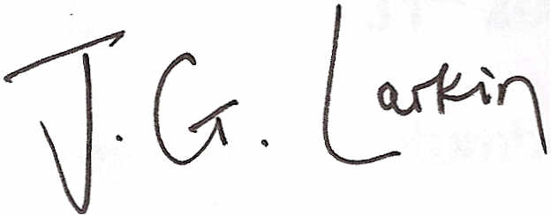
Director and Company Secretary

Note: This notice is issued more than one month before the meeting date
having regard to the need for compliance with the minimum 21-day period of
notice required to hold an annual general meeting of the company.

