Commissioning Intentions for London Ambulance Service (LAS) 2015/16
“Think like a patient, act like a taxpayer”
Simon Stevens, April 2014
Commissioning Intentions
Urgent & Emergency Ambulance Services provided by
London Ambulance Service
2015/16

The Urgent Care Context

Transforming Urgent and Emergency Care Services (The Keogh Review)
Since the initial Phase 1 Report (2013), the NHS England Urgent and Emergency Care Review group published an update report on the progress in implementing its vision for change.
A new, simplified and more accessible model for the delivery of urgent and emergency care needs to ensure all providers and commissioners within the pathway work together. High-quality care needs to be accessible where and when people most need it.
The proposed model sees urgent care needs managed by responsive services outside of hospital, and as close to home as possible – and therefore with a strong emphasis on primary and community care, and the role of ambulance services. Emergency care needs will be managed in centres that can provide access to the best expertise and with different levels of specialisation. This will maximise chances of survival, accelerate recovery and ultimately improve patient experience while relieving pressures on the system.

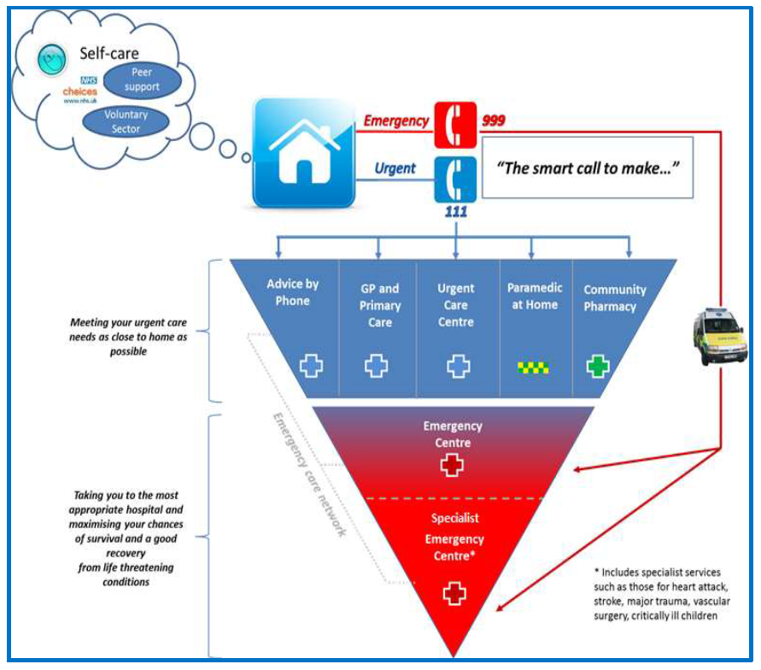

Priorities for the review are:

- Providing better support for people to self-care
- Helping people with urgent care needs to get the right advice in the right place, first time
- Providing highly responsive urgent care services outside of hospital so people no longer choose to queue in A&E
- Ensuring that those people with more serious or life threatening emergency needs receive treatment in centres with the right facilities and expertise in order to maximise chances of survival and a good recovery
- Connecting urgent and emergency care services so the overall system becomes more than just the sum of its parts

The Financial Context

The 2010 Spending Review set out a 0.4 per cent real-terms growth over the period 2010 to 2015 – 0.1 per cent a year. This represented the lowest four-year increase for the NHS since the 1950s (Emmerson et al, 2010). The £15 to £20 billion of efficiency savings required to manage within the Spending Review resource allocations between 2010 and 2015 equated to productivity growth of between four and five per cent per year.

Whilst health expenditure from 2015 to 2020 is likely to increase in real percentage terms, the relative funding pressure on the health system is likely to increase as demand on services and health inflation continues to rise at a faster rate. Simon Stevens refers to this as "the most sustained budget crunch in its [the NHS] 66 year history".

Figure 1: the NHS Funding Gap 2010 to 2020 (Source Lilley (2014))

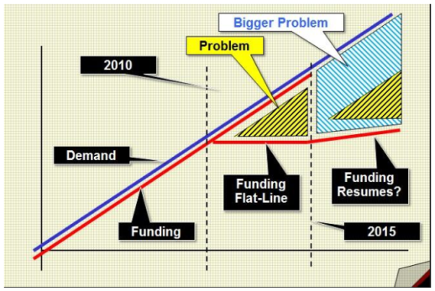

The general financial context is likely to present both opportunities and threats to LAS. Productivity growth will generally result in significant cost improvement programmes being required of all providers, however LAS will also provide an opportunity for health care to be provided ‘closer to home’ where overall costs can be lower.

Commissioning Priorities

Commissioners and the London Ambulance Service (LAS) will be expected to continue to modernise ambulance services, support the delivery of healthcare reform, deliver high performance when measured against the ambulance clinical quality indicators, and provide services that reduce costs within the wider emergency and urgent care system, all within the context of a financial environment of significant fiscal constraint.

The key commissioning priorities for 2015/16 are a continuation from the priorities outlined in the 2014/15 commissioning intentions; these are aligned to the LAS Integrated Business Plan, and focus on the system wide Quality, Innovation, Productivity and Prevention opportunities.
- LAS implementation of a revised model of care, optimising use of resources and clinical outcomes, responding to the National Audit Office review of ambulance commissioning, through:
  - Increased appropriate levels of Hear & Treat, utilising the benefits of 111 services.
  - Increased appropriate levels of ‘See & Treat’ and ‘See and Refer’ (to other non-acute services) maximising the use of the Directory of Service (DoS).
  - Consideration of the implementation of the use and development of NHS Pathways in the 999 Emergency Operations Centre environment.
  - Enabling workforce transformation, with appropriate skill mix and tasking. Commissioners continue to support LAS in enhancing the Paramedic workforce and increasing skill mix.
- 2014/15 has seen a deterioration in performance against Category A call response times, and Commissioners need to see a rapid and resilient recovery of performance; consistent timely Red 1 and Red 2 performance, for potentially life-threatened patients, regardless of season, time of day or location in London needs to be achieved through:
  - Full implementation of predictive capacity and workforce tool
  - Optimised tasking of ambulances (e.g. reduction in multiple vehicle attendance)
  - Workforce alignment (rosters, skill mix, annual leave, rest breaks etc.)
- Specific focus on Demand Management and fundamentally aligning LAS resources and systems, to enable the wider system to be able to:
  - Identify frequent callers/locations, and develop appropriate plans
  - Evidence to identify the need for appropriate alternative care provision
  - Tackle specific demand areas - Police, Public Transport, Alcohol, and Care Home referrals
- Strengthening clinical outcomes for patients across all care pathways,
  - Provision of patient level information (incl. NHS Number) to enable decision making by Clinical Commissioning Groups
  - Working with each Clinical Commissioning Group to support QIPP plans
  - Patient and public engagement and involvement in pathway development
The above priorities are underpinned by the CQUIN framework (worth c.£6.2m); proposed schemes are currently being developed by CCGs, in partnership with LAS.

Commissioning Principles

During 2015/16 the London Commissioners and the London Ambulance Service will be expected to deliver continued on-going process of modernisation of ambulance services, deliver healthcare reform, implement the new ambulance outcomes framework, and provide services that reduce costs within the wider emergency and urgent care system, all within the context of financial resources that have a real term decrease.

LAS must continue to be adherent to and achieve the aims of the Department of Health’s White Paper ‘Equity and Excellence: Liberating the NHS’. LAS will need to continue to work to put patients first, and to trust the health professionals that work in the service and with the service – only by doing this will we achieve improved value for money, better clinical outcomes, and a healthier population in London. Therefore:

- Patients will be at the heart of everything we do. “No decision about me, without me”.
- There will be a relentless focus on clinical outcomes
- LAS will empower health professionals by giving frontline staff more control. Healthcare will be run from the bottom up, with ownership and decision-making in the hands of professionals and patients.
- Despite the financial situation, the modernisation agenda must be accelerated and not abandoned.

London Ambulance Service will be expected to work in partnership with other healthcare providers to deliver a coherent 24/7 urgent care service in London that makes sense to patients when they have to make choices about how they access urgent and emergency care. Helping people make suitable choices about accessing urgent and emergency care will become more consistent using the Directory of Services (DoS), and associated information technology and access points (e.g. 111). NHS Pathways will continue to be the system for assessment of urgent patient needs via the 111 call route, and providers of healthcare will be expected to have their range of services and availability within the Directory of Services; Commissioners recognise that LAS use the AMPDS for the assessment of emergency care needs via a 999 call route. As a large volume of urgent care work comes in to LAS via the 999 route, it is important that LAS have systems aligned and joined up with the NHS Pathways system to maximise the opportunities of people with urgent care needs being directed to the Right Care First Time through the use of the London wide Directory of Services.

Strategic Alignment

LAS will be working with CCGs and other key stakeholders to develop a strategy to take ambulance services towards 2020.

LAS will need to continue to work closely with Clinical Commissioning Groups to ensure that the proposed model of ambulance service delivery fits the strategic aims and direction of CCGs in the short (1 year), medium (3 years) and long terms (5+ years); in addition, LAS will need to work with the evolving CCG networks of care, and System Resilience Group (SRGs).

LAS are an integral part of the emergency and urgent care system in London, and will need to play a part in the overall management of system demands in an environment of limited resources; integrating with other providers of ‘first contact’ services (e.g. primary care, 111, Out of Hours) is important to ensure that patients get directed to the right care first time.

Public and Patient Involvement

LAS is effectively a monopoly provider of urgent and emergency ambulance services for London; patients therefore have no choice over the ambulance provider that delivers their emergency care. We need to ensure that patients and the public have a voice by which they can influence the service that is provided. The ‘House of Care’ is one example of how a proactive, person-centred approach can be achieved. It is made up of four inter-dependent components:

Commissioning – driving quality improvement.
Engaged, informed individuals and carers – enabling individuals to be involved in all decisions about their care, to self-manage and truly say ‘No decision about me without me’.
Organisational and clinical processes – structured around the needs of patients and carers using the best evidence available.
Health and care professionals working in partnership – listening, supporting, and collaborating for continuity of care. Professionals starting with patients not services.

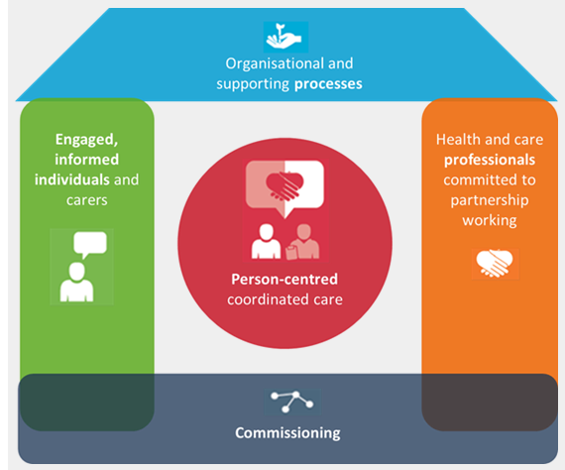

LAS is a significant provider of pre-hospital care, and as such CCGs expect LAS to involve:

- Patients and Carers in decisions relating to care and treatment
- The public in commissioning processes and decisions
- CCGs and health professionals as advocates of the patient interest

We expect LAS to work with patient forums, shadow Foundation Trust public members, Healthwatch (previously undertaken by LINks), and CCGs.
Intention – LAS and Commissioners will work with appropriate patient forums. The LAS Patient Forum will be used as an expert patient group that will be consulted on commissioning decisions

LAS must actively seek out, respond positively and improve services in line with feedback from patients and clinical commissioners. The Duty of Candour will be embraced, to ensure that where mistakes are made, these will be openly and transparently admitted with patients and service users, to ensure that lesson can be learned from these events.

The move towards Foundation Trust status will ensure that LAS is increasingly accountable to the local population. Commissioners support this local accountability, and the increasing involvement of local people in shaping the service.

We want to see people using the ambulance service appropriately. Commissioners recognise that people often don’t know when to use the service, or alternatives available. We need LAS to work with commissioners to develop programmes that will help our local population become more engaged and responsible users of the service.

Everyone Counts – Planning for Patients 2015/16

The healthcare system is facing the challenge of significant and enduring financial pressures. People’s need for services will continue to grow faster than funding, meaning that we have to innovate and transform the way we deliver high quality services, within the resources available, to ensure that patients, and their needs, are always put first. ‘Everyone Counts: Planning for Patients 2014/15 to 2018/19‘ sets out the framework within which commissioners will work with LAS and partners to secure the continuity of sustainable high quality care for all. LAS will be expected to deliver against the priorities set out in this document.

Specific commissioning themes are set out below:

- Performance

A responsive ambulance service is critical for emergency patients. We expect LAS to exceed the time critical standards:

- 75% of Red 1 (life threatening) category A calls having an emergency response arrive within 8 minutes
- 75% of Red 2 (potentially life threatening) category A calls having an emergency response arrive within 8 minutes
- 95% calls requiring a patient transport, result in an ambulance arrive at scene within 19 minutes

We expect LAS to be consistently delivering system and outcome indicators that are in the upper half when compared to other ambulance organisations in England, and as a result LAS will be regarded as an organisation that is ‘best in class’ when benchmarked against other ambulance services in England.

We want staff within the service and Commissioners to focus on delivery of improvements in clinical outcomes. For the last few years we have concentrated on system indicators to the point where this is now firmly embedded in organisations. The same attention to clinical outcomes is now developing, and LAS are leading on work that will continue to drive improvements in clinical outcome. CCGs will work constructively with LAS, , NHS England (London), DH, TDA, the National Ambulance Commissioners Group (NACG) and the Association of Ambulance Chief Executives (AACE) to develop a more robust and comprehensive range of clinical indicators that measure overall performance of LAS and ambulance services generally.

Financial Performance

London Commissioners recognise that LAS are aspiring to be a Foundation Trust (FT), and this will require a degree of financial rigour that has hitherto not been in existence; Commissioners are supportive of the move to FT status and will work within the financial regimens that will be required to achieve this, including the achievement of surplus and EBITDA.

We want LAS to have an open and transparent approach to financial management, so that cost effectiveness can be demonstrated. Commissioners also need to be aware and have assurance that surplus accrued is invested in line with the strategic commissioning intent.

LAS need to be seen as an organisation that constantly maximises the outputs from the investment of commissioners, and particularly commissioners want to see the added benefit to the healthcare system.

LAS and Commissioners have looked at different methods of payment mechansims, including Payment by Results (PbR) methodology. During 2012/13 the pbR methodology was shadowed, recognising four tariffs (call handling, hear and treat, see and treat, see and convey); this shadowing system didn’t produce a methodology that provides a consistent means of paying for ambulance activity, and LAS has therefore been maintained using a block contract of ran identified number of incidents. Each CCG pays for an element of the contract cost based on an average of activity over a preceding three year rolling period. During 2015/16 there is no intention to change this methodology.
Intention - During 2015/16 we will be undertaking work to move the funding methodology in future years away from a single block to a triple funding stream:

- a substantial proportion of fixed core funding, to reflect the ‘always-on’ nature of the LAS services and to concentrate attention on planning capacity across the system to specified minimum access and quality standards, in line with the vision of the Keogh Review.
- a proportion of volume-based funding, to make it possible for LAS to manage unpredictable fluctuations in demand and to share in the financial impacts of their actions on the system as a whole, as well as to enable risk to be allocated between LAS and commissioners. The volume-based payment method will incentivise the right interventions as recommended in the House of Commons Emergency Services Review (recommendations 151).
- using LAS-specific and system-wide quality metrics as eligibility criteria for different rates of fixed and volume-based funding, and as the basis for bonuses and penalties, to support service changes and promote quality improvement.

LAS are currently funded to provide two Hazardous Response Teams (HART). These teams provide mutual aid, and whilst funded locally are seen as a national resource overseen by the National Ambulance Resilience Unit (NARU). To maintain clinical competence and skills, LAS may use HART teams on a planned basis to respond to emergency calls; this is supported but should not be to the detriment of the emergency preparedness capability.
Intention - We do not intend to make any local changes to the specification or funding of the HART teams.

We expect LAS to have a robust plan for delivering services within the envelope of cash available, and that end of year financial balance will be delivered.

LAS is expected to deliver responsibilities within the overall cash available. Commissioners will not expect LAS to be dependant on funding outside of this source to deliver the requirements of the contract. Additional investment resource may be made available via the System Resilience Groups and this resource needs to be outside of the contract.

The contract is seen to deliver the cash required to deliver support for events that can be reasonably expected (e.g. public events not otherwise funded, royal visits, political party conferences, state visits etc). During the year, unplanned civil contingencies may occur that LAS need to ensure they can resource through the overall resource within the contract; only where events could not be reasonably forseen (e.g. force majeure) will CCGs consider additional funding requests.

- Quality-Innovation-Productivity-Prevention (QIPP)

We expect LAS to develop a specific QIPP plan that demonstrates how an ambulance service will deliver the joint ambitions of QIPP schemes across London, and specifically:

Quality
- Work in partnership with all healthcare providers to ensure robust delivery of the five domains of the NHS Outcomes Framework
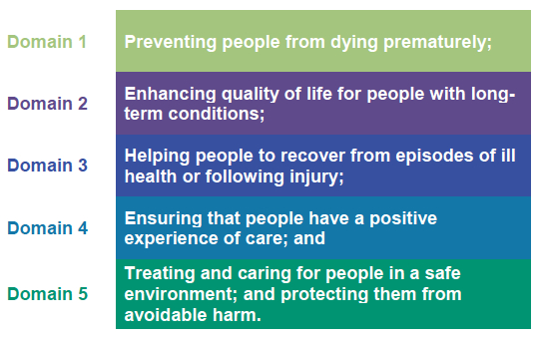
- Seeks to improve the quality of services through innovation
- Improves clinical quality and outcomes
- Enhances patient experience
- Develops improved systems of infection prevention

Innovation
- Develops new systems of care delivery in a managed way
- Continue the implementation of appropriate clinical trials
- Supports system innovation e.g. Implementation of 111
- Continued development of the CMS DoS to support system reform

Productivity
- Delivers in the top quartile of ambulance trusts when benchmarked against measures of productivity
- Responds to and delivers against recommendation in the National Audit Office review ‘Transforming Ambulance Services’ (2011)
- Delivers against agreed productivity metrics, to include:
  - Reduced times for patient handover at acute hospitals
  - Enhanced dispatch regimes to reduce multiple attendance ratios
  - Reducing overall job cycle times
  - Increasing the number of calls managed without dispatch
  - Increased numbers of calls that are managed through alternative care pathways without dispatch of an ambulance vehicle
  - Decreasing re-contact rates
- Ensuring dynamic rostering to match incident demand
- Working with Capacity Management Systems to ensure that ‘intelligent conveyance’ of patients across London is achieved.

Prevention
- Continuing to develop the Directory of Services so that people who ring 999 can receive the most appropriate service for their needs
- Support the implementation and development of the 111 service
- Continue to work with Commissioners to understand the nature of 999 demand and how this can be reduced (e.g. tackling Demand together Toolkit)
- Work with commissioners to manage demand from high using establishments e.g.:
  - Police Stations
  - Retail Outlets
  - Railway Stations
  - Leisure Facilities
  - Nursing Homes
- Continue to proactively work with people who are high users of the service (to be locally defined), so that people with specific needs can be managed more effectively.
- Work proactively with partner organisations to proactively manage specific demands on ambulance services e.g.:
  - Excess alcohol consumption
  - Violent crime, especially gun and knife crimes
- Develop the work of the community responders, and continue roll out of community defibrillator provision and training
- Work with targeted community groups to develop skills in how to use an ambulance service, and alternative ways to deal with incidents (this may be a CQUIN scheme)

- Clinical Commissioning

The 32 CCGs across London are responsible for the commissioning of ambulance services.
Intention - The CCGs will continue to work on a Consortium arrangement to deliver a robust commissioning infrastructure for LAS.

CCGs will also be driving the delivery of the local urgent care agenda, and ambulance commissioning is an integral component of urgent care. Nationally, ambulance services cost over £1.8 billion, but have a system impact in excess of £20 billion. Increasingly, people are using ambulance services as a first point of contact for urgent care needs, and it is essential that the LAS models for ambulance services is developed to ensure service users receive the right care in the most appropriate place.

The National Ambulance Commissioning Group has been refreshed to take account of the new commissioning landscape, and is now led by CCGs under the umbrella of the NHS Clinical Commissioners, an organisation co-hosted by the NHS Alliance and the NHS Confederation. The NACG will continue to work collaboratively with the Association of Ambulance Chairs and Chief Executives (AACE) to develop national work-streams for service improvement’ and we welcome the active involvement of LAS in this process.

Clinical Engagement

We have seen a development of the clinical quality review process as a means to get improved clinical engagement. We would like to see further developments in clinical engagement by building on the work that LAS has undertaken over the past few years. Clinical engagement is important to enable LAS to:

- Develop appropriate pathways
- Manage clinical risk
- Develop the clinical skills of staff – e.g. by getting feedback from Hospital Consultants
- Ensuring patient clinical needs drive priorities of care
- Developing enhanced expertise on the interventions that benefit patients
- Identifying clinical colleagues who use the service to ensure their use is most appropriate

We want to see that LAS have engaged with clinicians to support any plans for cost reduction so that those plans have proper clinical risk assessments made.

The central forum for clinical engagement will be the Clinical Quality Review Group. LAS are active participants in this process, but clinical engagement from CCGs has been sporadic. Commissioners will be seeking an increased representation from clinicians in the Clinical Commissioning Groups for 2015/16.

- Dignified and Compassionate Care

LAS must work pro-actively to deliver care that is patient focused and compassionate; on occasions, this will require a change in mindset to ensure that patients get the right care

“Each patient’s experience is the final arbiter in everything the NHS does” (Operating Framework 2012/13).

Continued improvements in end of life care

LAS has been an active participant in the Pan-London project to improve end of life care (Co-ordinate my Care); where this works, it works very well, but on occasions despite plans being in place, patients are inappropriately resuscitated or taken to hospital. The capacity of the LAS to respond to ‘end of life’ care plans needs to continue to increase and Patients with specific care plans must be treated according to their plan and, where patients have specific needs, they must be transferred to the appropriate specialist clinical service, hospice or social care facility.
Intention - We want to see LAS giving greater emphasis on driving improvements in palliative and end of life care:
- Patients who are end of life are conveyed with drug administration equipment intact e.g. syringe drivers.
- Patients who are actively dying are conveyed within 2 hours of request.

During 2014/15 a collaboration involving The London Cancer Alliance, LAS, North West London Commissioning Support Unit and representatives of the London CCGs have produced a proposal for improving urgent ambulance transport services for palliative and end of life patients (see referenced documents). Commissioners want to see this work implemented to ensure the needs of this important group of patients are met.

Improvements in Mental Health Care
Intention - We want LAS to implement the proposals contained in the collaborative document Optimising Patient Transport when it Matters - a proposal for improving urgent ambulance transport services for palliative and end of life patients

During 2014/15 significant progress has been made by the LAS following the decision by the Commissioners to give some priority to mental health care. To continue this development LAS should develop a specialist team of paramedics and nurses who are expert in the care of patients with a mental health diagnosis. All frontline staff should be required to be continuously and dynamically trained in the care of people with mental health problems, bearing in mind the special needs of people with learning difficulties and the need focus on cultural, language and age related issues

The Independent Commission on Mental Health and Policing was chaired by Lord Victor Adebowale; It is reviewed the work of the London Metropolitan Police Service in relation to how the police interact with people with mental health problems. The Commission made specific recommendations about the delivery of ambulance services:

- No person is transferred in a Police van to hospital
- LAS give consideration for provision of dedicated Mental Health Paramedics
- LAS review call prioritisation so that there is parity of esteem between mental health and physical health
Intention - LAS need to consider the recommendations contained in the Report by the independent commission on mental health and policing and demonstrate how they have made changes to the service delivered to this client group.

Dementia Care

The number of people with dementia is increasing; ambulance crews are often the first point of contact for with people with dementia, who may come to the attention of the service as a result of primary incidents such as falls. We need LAS staff to have increased knowledge and awareness of dementia to assist in the identification of patients who require dementia-appropriate community services, and initiation of appropriate liaison / links with these services. There should then be fewer unnecessary admissions for patients with dementia to hospitals as a result of collaborative work between the ambulance service and health and social care organisations.

LAS need to have access to clear effective dementia pathways for patients, in collaboration with hospitals and where possible community care professionals, to ensure ‘right care first time’ for patients with cognitive impairment.

Services for Patients who are heavily Under the Influence of Drugs or Alcohol

Commissioners want to see a development in health services provided for people who are substance intoxicated. We want to see LAS at the forefront of this development working in partnership with other expert providers of health and social care and alcohol and drug charities. Providing care in areas where substance intoxication is common, provides potential access to safeguarding, relieves pressure on emergency services and enables staff to signpost patients to alcohol counsellors to address substance misuse.

- A Safe, Responsive and Responsible Organisation

Patient Safety

CCGs want LAS to provide a safe and high quality that is responsive to patient and carer needs. As part of this responsibility, CCGs want to ensure the following;

Workforce and Workforce Development

LAS currently have a shortage in the Paramedic workforce, and this will present a huge challenge to delivering the priorities in the service. CCGs have supported LAS in their current recruitment drive in Australia and New Zealand providing a short term opportunity to enhance the paramedic skill mix. CCGs will continue to support LAS, and will work with Health Education England to address a national shortage in the number of Paramedics being trained and joining the HCPC register. CCGs want to see LAS consider longer term solutions that will concurrently address issues of social deprivation and local regeneration. By working with communities in deprived parts of London, we want to see LAS working in partnership with education providers to enable people who have otherwise been excluded from opportunities, to be able to develop educational and vocational qualifications that enable them to work at LAS.

We expect LAS to continue to deliver the trajectory for enhanced clinical skill mix. To ensure that every frontline ambulance has a qualified paramedic on board, as recommended in the House of Commons Emergency Services Review (recommendations 139 and 152), LAS will need 70% of the front-line workforce to be Paramedic trained. LAS should aim to attain this skill mix as a matter of priority.
Intention – 70% of the front-line workforce to be Paramedic qualified by 2017
We support the development of enhanced roles, so that paramedics have additional skills to assess, diagnose and treat patients outside of hospital. It is also important that staff have appropriate skills to ensure that patients are conveyed to the appropriate place for further treatment.

Intention – Commissioners support the recommendations contained in the Paramedic Evidence-based Education Project (PEEP) Report (2013) and:
- Want to see all Paramedics trained at BSc level (Level 6) from 2015.
- Support the need for the majority of Paramedics to be banded at AFC Band 6
- A direction of travel of an all graduate profession by 2019.
We welcome diversity in our communities in London and within the workforce of LAS. Diversity is a positive factor in a healthy community, and we welcome the efforts being made by LAS to have a workforce that reflects the diverse nature of London.

LAS must ensure full compliance with the Equality Act 2010 and it’s associated public sector Equality Duty evidenced through the utilisation of the Equality Delivery System.

The LAS workforce needs to have continuing professional development so that all staff have the ability and the confidence to undertake their role to improve patient care and clinical outcomes, whether in a frontline or supporting role.

We want staff to have the ability to confidently manage clinical risk. By avoiding risk, and taking patients unnecessarily to hospital, we create a system that has more risk overall. Confident professional clinicians are expected to use clinical judgement to make appropriate decisions.

We want LAS to be an organisation that values and looks after staff. Complying with the European Working Time Directive, ensuring staff take meal breaks, and ensuring appropriate annual leave is taken are important factors to ensure we have a workforce with a good work life balance.

We want to see a workforce that is healthy. LAS has an important role as a health provider, and a model employer, and staff should be encouraged to seek health-promoting activities compliant with the Boorman review (2009).

LAS have some challenging times whilst making significant modernisation changes. Commissioners recognise that for some staff this may be difficult, and disrupt established ways of working; we want LAS to work pro-actively with staff and ensure that the risk of industrial action is minimised. LAS need to help staff recognise the need for change if the organisation is going to be fit for purpose and financially viable moving forward.

The staff survey is an important way of identifying how LAS can make improvements to working environment; using the staff survey to make improvements is an important element of improving patient care.

Data / Reporting

We want LAS to provide consistently high quality data that is used to constantly improve patient care and clinical outcomes. Where possible, we want data to be live data, presented in ways that allow commissioners to use the information to make changes to patient care.

No single technical change has greater power to improve the integration of services than the consistent use of the NHS number. Since the 2012/13 DH Operating Framework (section 3.29), all NHS organisations have been expected to use the NHS number; for ambulance organisations this has proved a challenge, and a continued drive towards this goal is required.

Ensuring that all ambulance crews have access to national patient data would increase the patient information that is available to allow for better decisions to be made regarding conveyance and care (recommendation 148 in the House of Commons Emergency Services Review ; LAS will need to work with Urgent Care Boards to enable access to enable access to the patient records for ambulance staff so that patients are treated in the most appropriate place first time.

We appreciate the value that LAS give to quality information. The use of current and historical information is important to allow the local healthcare system to plan and deliver. This is even more critical at times of high demand.

Service Change

We will constantly re-evaluate services to ensure that they are delivering clinical and cost effective outcomes. Each year we will test elements of the service to ensure that it is delivering best value.

Service developments for 2015/16 will be limited, except via agreed CQUIN schemes. Any plans for service development need to be submitted by 1st December 2014, and only those that deliver strongly when assessed against CCG priorities will be considered.

During 2015/16 we are likely to see service reconfigurations across health economies in London; LAS will play a critical role in the success of these service reconfigurations, and it is important that LAS plays an active part in service modelling as well as working in partnership with commissioners, acute hospitals and other health and care services to implement proposed changes.

Social and Environmental

We want to see a service that provides equity of access, meeting the different needs of the people who live in London, and those that visit. LAS need to consider the needs of those with language needs, as well as people who have a disability.

LAS needs to be an ethical provider of healthcare and a responsible employer exercising a social responsibility. Reducing carbon footprint is an important part of being a good corporate citizen.

Emergency Preparedness

LAS will play a critical role in the overall emergency preparedness of London, and the whole of the UK.

As the provider of ambulance services in the capital city, LAS is required to maintain world class standard of preparedness to respond safely and effectively to a full spectrum of threats, hazards and disruptive events, such as pandemic flu, mass casualty, potential terrorist incidents, severe weather, chemical, biological, radiological and nuclear incidents, fuel and supplies disruption, public health incidents and major events.
Intention – Maintaining the 2 HART services across London. Commissioners do not anticipate any changes to the current funding arrangement for the two HART teams. LAS will be expected to undertake the recommendations of the recent HART Stage 3 review co-ordinated by the National Ambulance Resilience Unit.

LAS will ensure that the HART teams are fully operational 24/7 and can demonstrate their role in the emergency preparedness environment.
Commissioners will work with LAS to undertake a review of the MERIT service. Working in partnership with other potential providers we will evaluate the overall robustness of this element of the emergency service. In particular we want to ensure that all providers of pre-hospital medical care (e.g. HEMS, Basics, MERIT) are facilitated to deliver a robust and comprehensive service by collaborative working.

CQUINS

We anticipate that the value of the CQUIN schemes for 2015/16 will be 2.5% of out-turn value. We want to work in partnership with LAS to define the appropriate schemes.

Associated Reference Documents (hyperlinked)

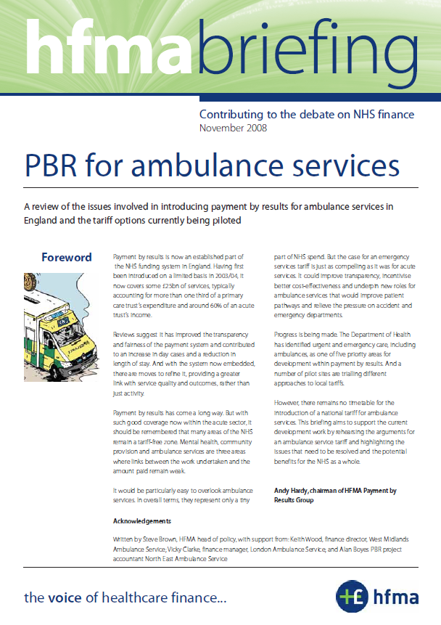 | 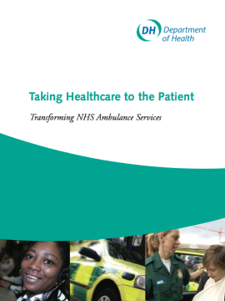 | 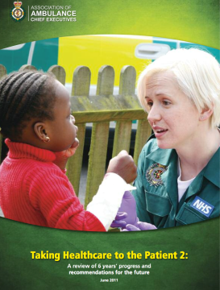 | 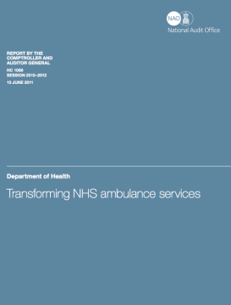
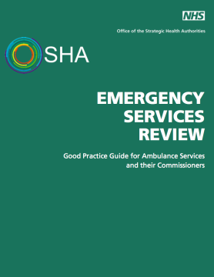 | 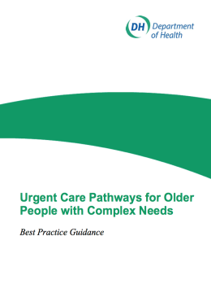 | 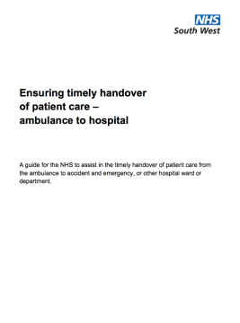 | 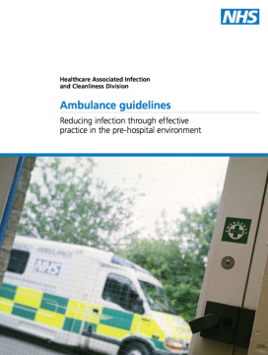
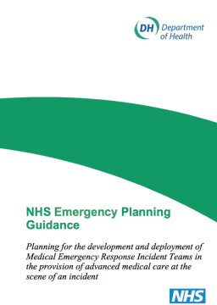 | 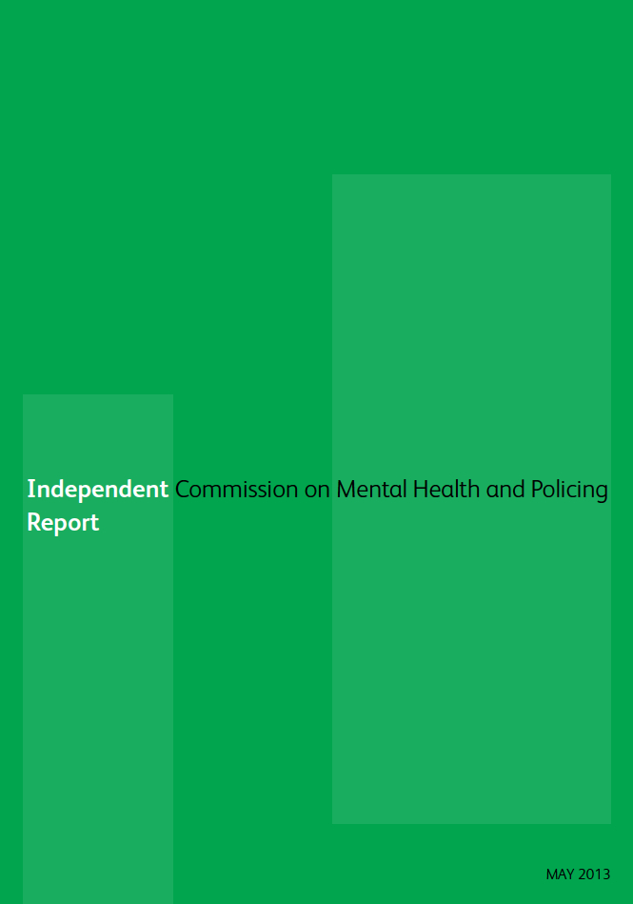 | 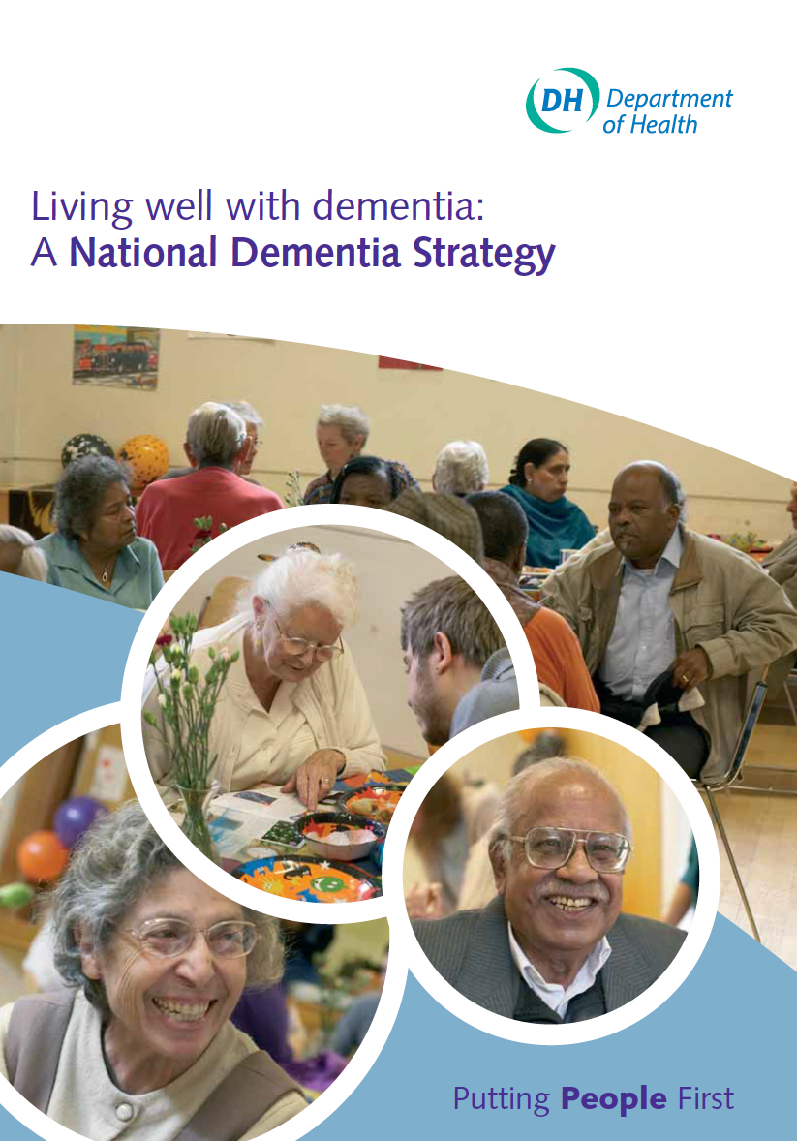 | 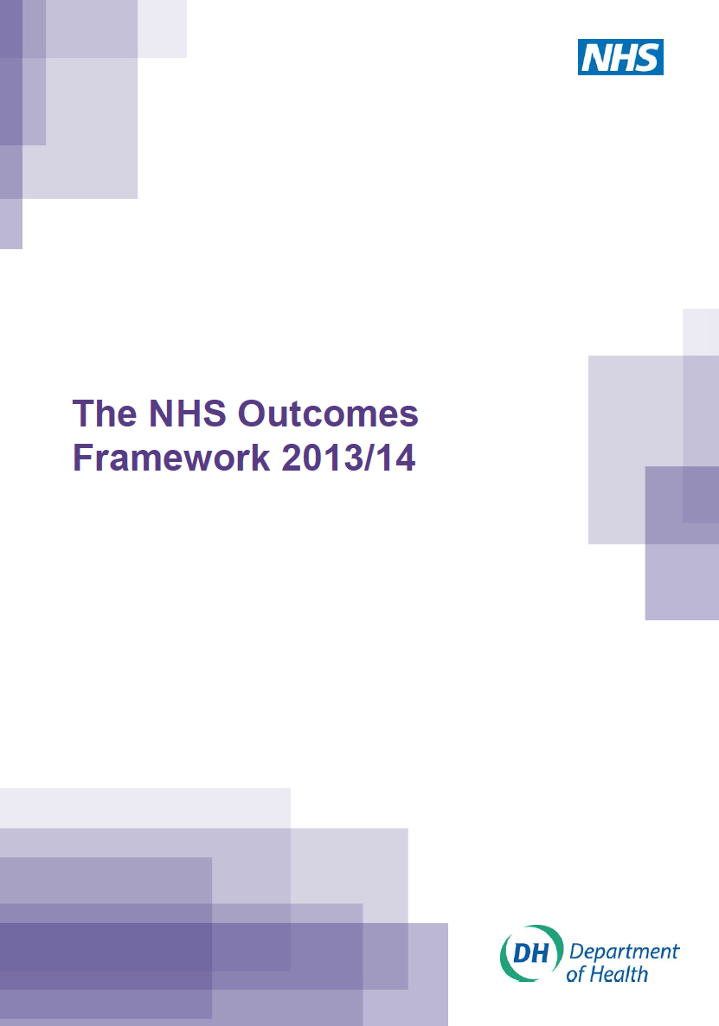
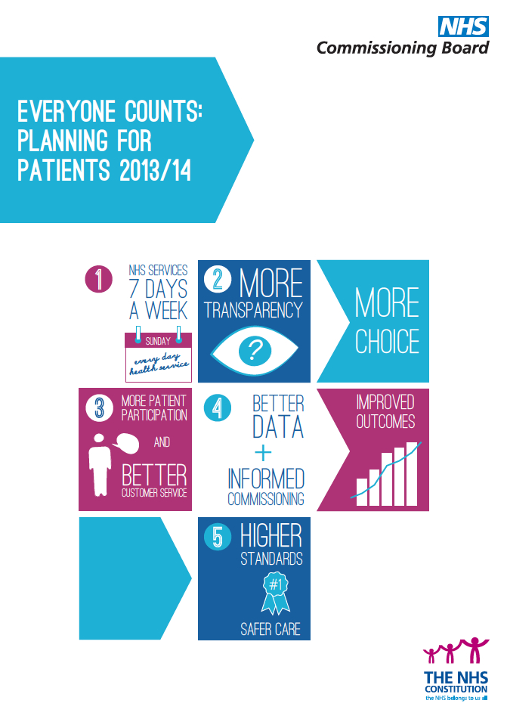 | 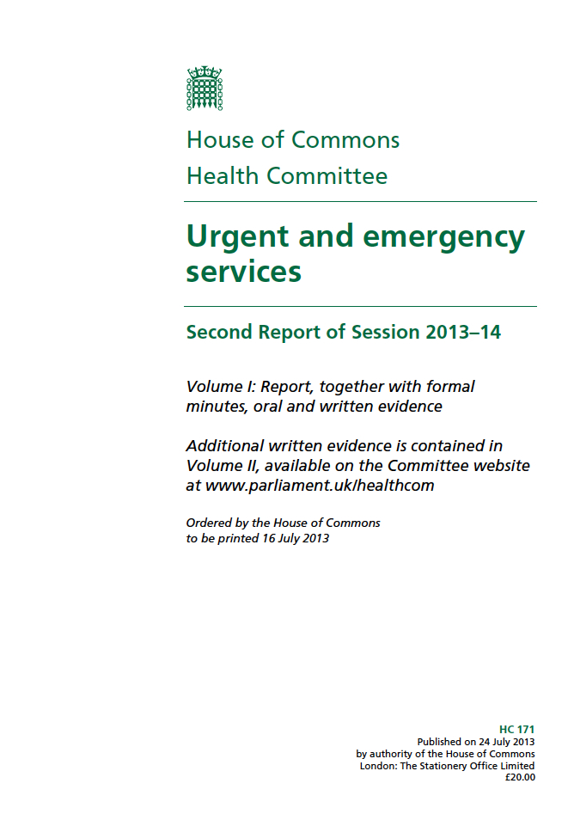 | 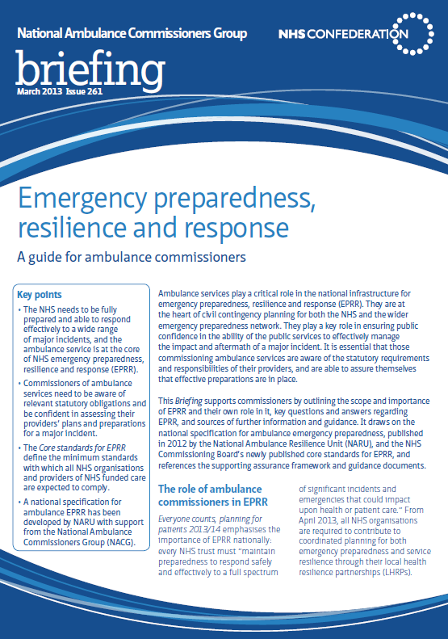 | 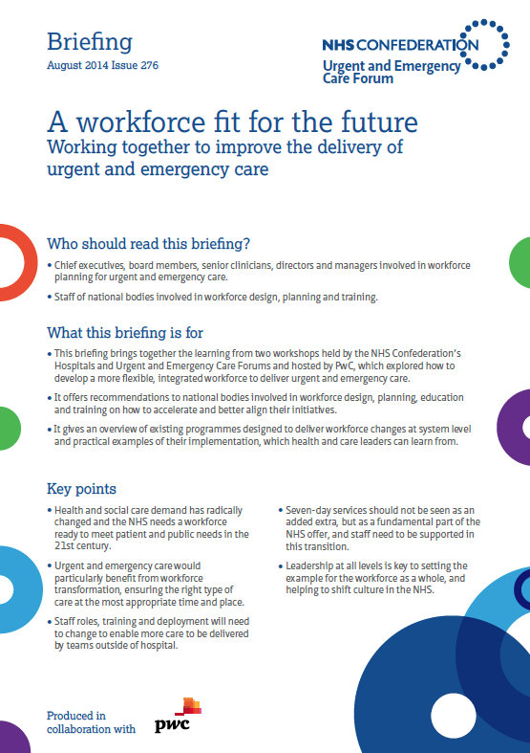
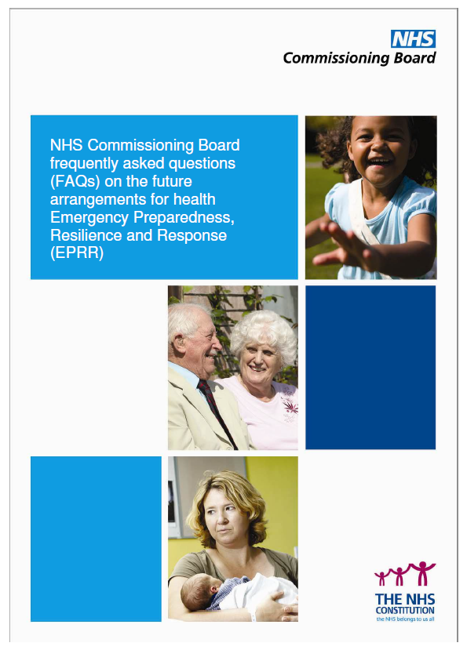 | 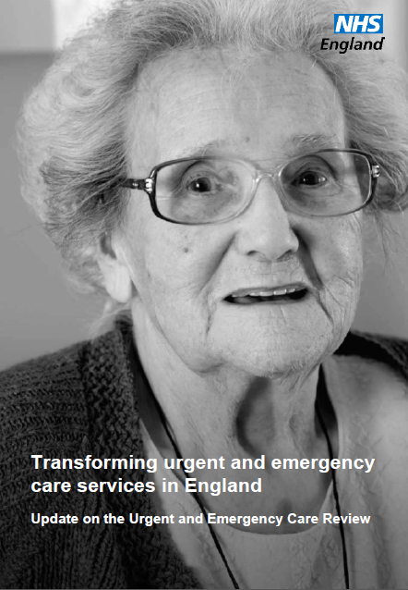 | 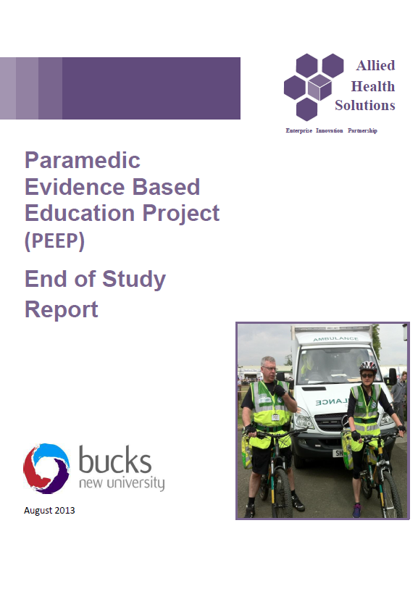 | 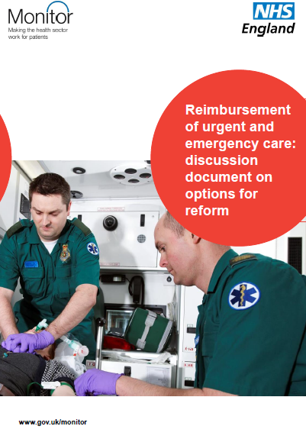
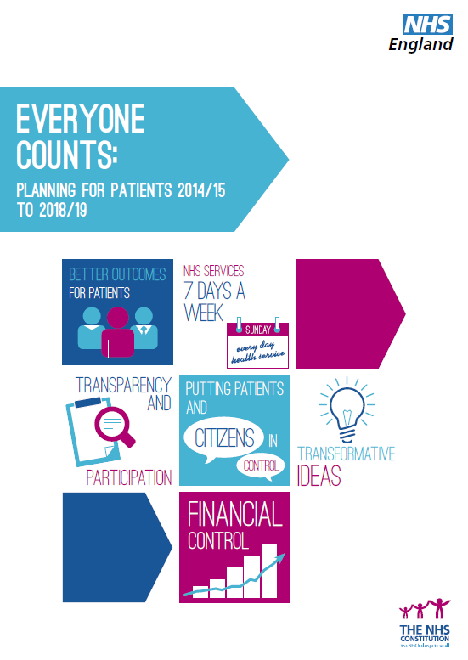 | 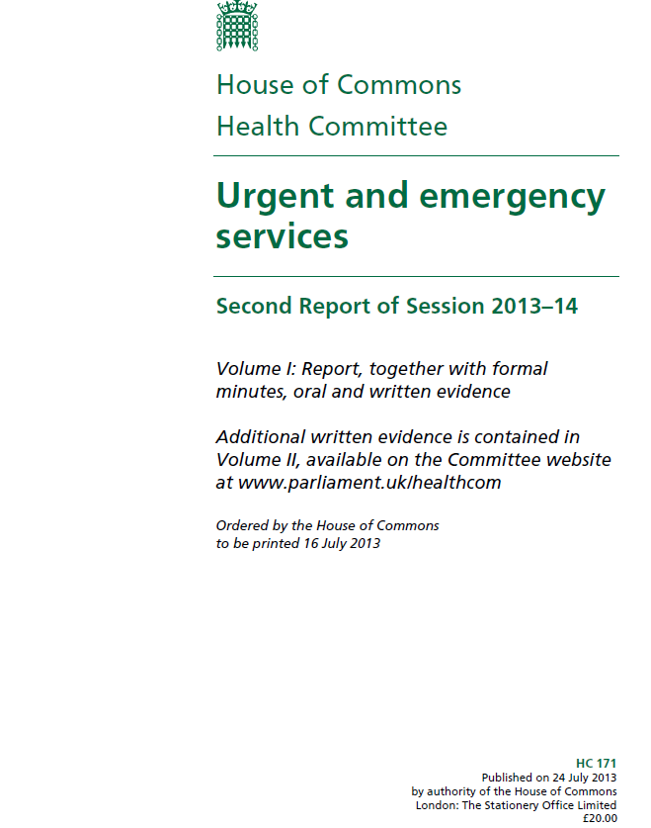 | 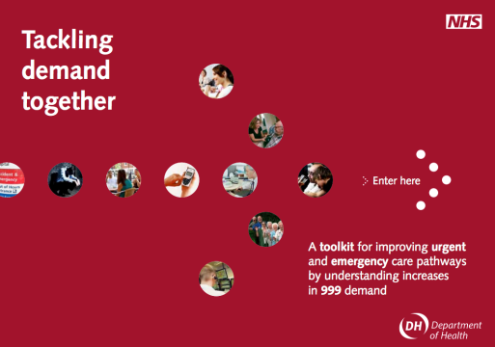
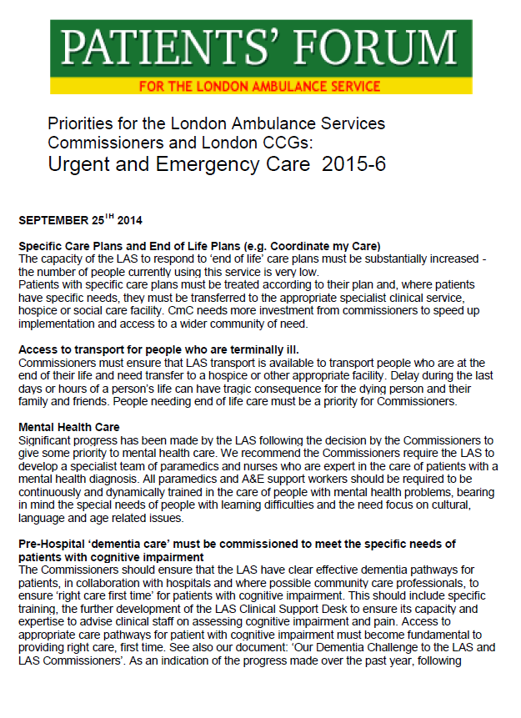 | 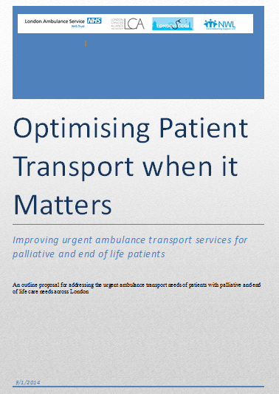 | 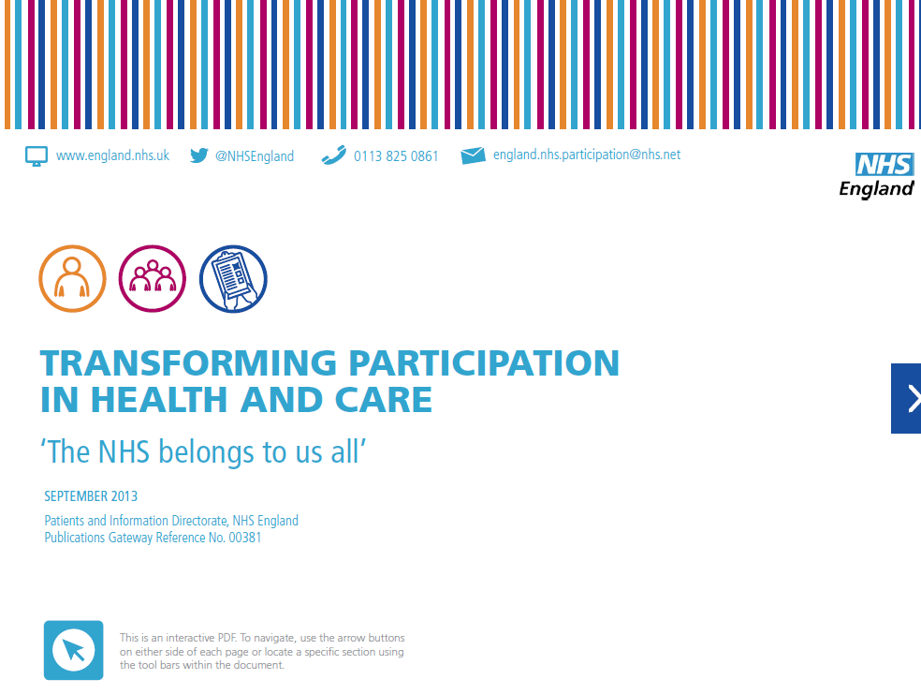
References

Emmerson C, Crawford R, Brewer M, Brown J and O’Dea C (2010) Spending Review 2010. Institute for Fiscal Studies.

Lilley (2014) cited in - Flip Chart Fairy Tales Business Bullshit, Corporate Crap and other stuff from the World of Work - Fiddling while the NHS burns http://flipchartfairytales.wordpress.com/2013/07/12/fiddling-while-the-nhs-burns/

