FLU VACCINATIONS
With regards to your query on Flu for 2017/18: Award against this indicator is available in full at the end of Q4 and will be assessed against national criteria and achievement of 70% vaccination uptake across eligible staff.

The 2017/18 flu Programme ran across LAS from 03 October - 28 February 2018. As part of agreements reached through CQRG, LAS reported across the whole organisation and the nationally defined CQUIN cohort of eligible staff.

Of the total staff count across the whole organisation, 53.5% individuals were vaccinated. Of the eligible staff within the CQUIN parameters issued by NHS England, 56.9% of staff were vaccinated.

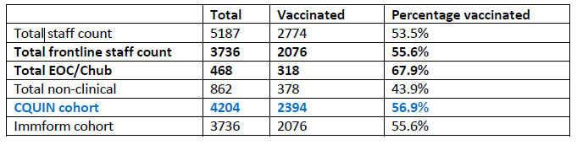

Therewere a total of 117 exclusions based on allergies and pre existing medical conditions. In Q3, to enhance uptake rates across the Trust , LAS undertook a series of targeted actions to improve uptake, including increasing the number of 'flu clinics' available to staff across London, incentives for vaccinators to undertake additional clinics and service wide communications on uptake and associated gaps, also published on a sector by sector basis. In addition the flu team concurrently sought to identify reasons behind poor uptake which have informed the 2018/19 Flu Programme.

Actions underway for 18/19 include:

Review of lessons learnt from previous year – in particular the need to improve communication with staff about the effectiveness of the vaccine, benefits to staff , families and vulnerable patients.
Review of promotional materials that can be used across this Programme

A further update will be provided as part of the Q2 evidence submission expected in October.

Thanks

Katy Neil
Brent CCG, Commissioners for the LAS

