**LAS Commissioning Weekly Update**

**9th January 2015**

**LAS Performance**

|  |  |  |  |  |  |  |  |
| --- | --- | --- | --- | --- | --- | --- | --- |
|  | **Category A** | | | **Red 1** | | **Red 2** | |
| Week to date figures for 19/12/14 – 25/12/14 | Incidents | % reached in 8 mins | % reached in 19 mins | Incidents | % reached in 8 mins | Incidents | % reached in 8 mins |
|
| **LAS Total** | **10624** | **51.54%** | **86.36%** | **367** | **64.85%** | **10257** | **51.07%** |

|  |  |  |  |  |  |  |  |
| --- | --- | --- | --- | --- | --- | --- | --- |
| **LAS Total**  Week to date figures for 26/12/14 – 01/ 01/15 | **10282** | **52.30%** | **87.82%** | **344** | **63.66%** | **9938** | **51.91%** |

|  |  |  |  |  |  |  |  |
| --- | --- | --- | --- | --- | --- | --- | --- |
| **LAS Total**  Week to date figures for 02/01/15 – 08/01/15 | **9673** | **53.52%** | **87.48%** | **307** | **61.89%** | **9366** | **53.25%** |

LAS Cat A weekly performance is currently at **53.52%** and YTD performance at **59.88%** which represents one of the lowest performing weeks this year. Over the Christmas and New Year period LAS produced additional hours to meet the demand. Weekending 4th January saw LAS record 357 occurrences of crews arriving at hospital to patient handover and waiting over 60 minutes or more and continues to have significant impact on operation capacity.

Cat A Performance tail

The “Cat A performance tail” is monitored as an indicator of safety during periods of underperformance. Using the diagram below , LAS achievement against the 75% target is within 11 minutes and 95% within 20 minutes (YTD).

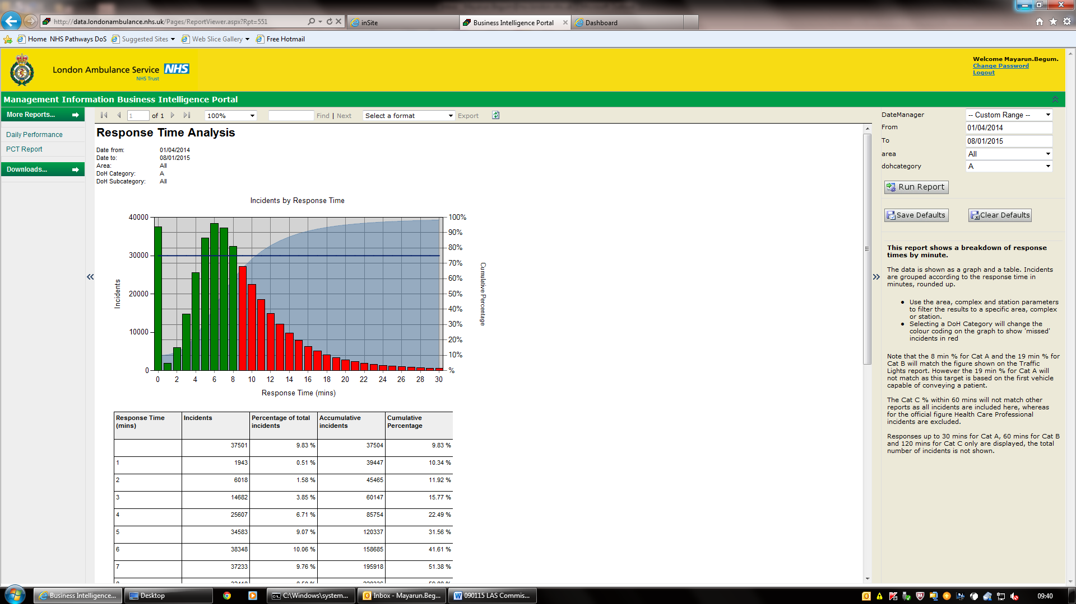

**LAS Updates & Reports**

Please see below the Weekly Exception Report provided by the LAS for week ending 4th January 2015 and the Falls Care Homes reports.

**  **

**News and Statements from the LAS**

**London Ambulance Service saw a 21 per cent drop in calls across the capital compared to last year but attended a similar number of seriously ill and injured patients during New Year’s Eve celebrations.**At peak times, emergency call takers were answering around 450 calls an hour, compared to over 600 last year. And there were 40 per cent less incidents in the central London event area compared to last year. 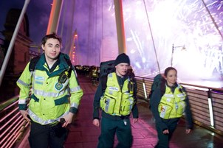

But, between midnight and 5am, ambulance crews attended 568 Category A patients – the most seriously ill and injured people. This compared to 589 last year.

Deputy Director of Operations Kevin Brown, who led the Service’s response on New Year’s Eve, said: “It has been an incredibly busy night for us, as we normally only receive around 250 calls an hour.”

To help manage the increased demand, the Service worked with St John Ambulance to run 11 treatment centres in central London where staff treated 195 patients and took 64 to hospital up until 5am. Most of the patients in the centres had alcohol-related illnesses or injuries. Many were helped to sober up and treated for minor injuries before being discharged. In the busy central London area medics worked on foot in teams of three with St John Ambulance volunteers, carrying full medical equipment with them.

Kevin added: “Every year we work closely with St John Ambulance at temporary treatment centres to ensure people out celebrating receive the most appropriate medical care as quickly as possible. By caring for people in treatment centres we can avoid taking them to busy A&E departments."  
  
**New Year's figures**

The Service’s control room usually takes an average of 250 calls an hour. The breakdown of calls per hour was as follows:

**New Year’s Day**

|  |  |  |
| --- | --- | --- |
| Hour | No of calls received New Year’s Day 2015 | No of calls received New Year’s Day 2014 |
| 00.00 – 01.00 | 357 | 469 |
| 01.00 – 02.00 | 457 | 604 |
| 02.00 – 03.00 | 469 | 612 |
| 03.00 – 04.00 | 409 | 491 |
| 04.00 - 05.00 | 350 | 412 |

**Team Contacts**

|  |  |  |  |
| --- | --- | --- | --- |
|  |  |  |  |
| Elizabeth Ogunoye | Team Director | 0203 350 4219 | elizabeth.ogunoye@nw.london.nhs.uk |
| Katy Neal | Head of Performance | 0203 350 4229 | [katy.neal@nw.london.nhs.uk](mailto:katy.neal@nw.london.nhs.uk) |
| David Whale | LAS Contract Performance Manager | 0203 350 4053 | [david.whale@nw.london.nhs.uk](mailto:david.whale@nwlcsu.nhs.uk) |
| Julian Williams | Directory of Service Lead | 0203 350 4605 | [julian.williams@nw.london.nhs.uk](mailto:julian.williams@nwlcsu.nhs.uk) |
| Stephanie Grant | Product specialist 111 /OOH/UCC contracts | 0203 350 4171 | [stephanie.grant@nw.london.nhs.uk](mailto:stephanie.grant@nwlcsu.nhs.uk) |
| Mayarun Begum | Project Officer | 0203 350 4752 | [mayarun.begum@nw.london.nhs.uk](mailto:mayarun.begum@nwlcsu.nhs.uk) |
| William Sheppard | Team Administrator | 0203 350 4174 | [william.dunbar-sheppard@nw.london.nhs.uk](mailto:william.dunbar-sheppard@nw.london.nhs.uk%20) |
| Yogesh Jagal | Share Point Lead | 0203 350 4187 | [yogesh.Jagal@nw.london.nhs.uk](mailto:yogesh.Jagal@nw.london.nhs.uk) |