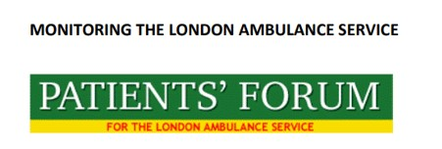
ANNUAL GENERAL MEETING
Tuesday, 01 November 2022 at 5.15pm
Zoom Link: https://tinyurl.com/3nfxa53n

AGENDA

- To be RESOLVED that the Reports and Financial Statements of the Company, for the years ended 31 December 2019, 2020, and 2021 be and are hereby received and adopted by the meeting:

- To be RESOLVED that John Garth Larkin, as a Director retiring by rotation in pursuance of the Company’s Articles of Association, and being eligible for re-election, be and is hereby re-elected as a Director of the Company.

- MENTAL HEALTH CRISIS IN OUR A&E DEPARTMENTS – 12 HOURS PLUS WAITS
Speakers:
- Marie Gabriel – Chair, NEL ICB
- Paul Gilluley – Nel, Chief Medical Officer
- Dean Henderson – ELFT Mental Health Trust

You may submit questions to the Speakers in advance of the meeting.

Dated this 11th day of October 2022
By ORDER OF THE BOARD
John Larkin – Director and Company Secretary

