**Performance Overview   
Key Metric Variation**



gggg

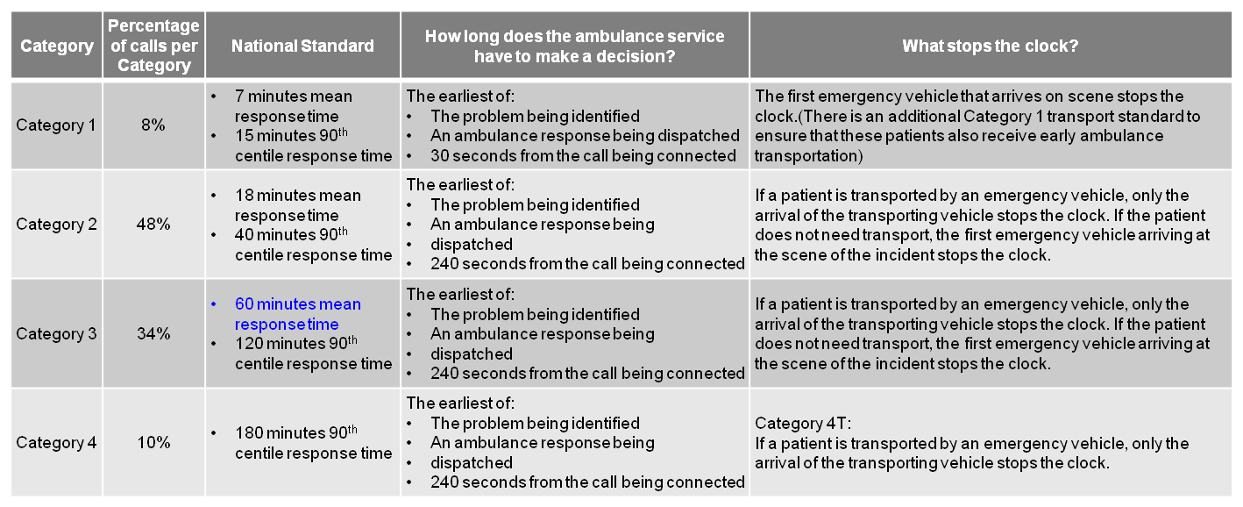

Since February 2015, three other ambulance services - South West, Yorkshire and West Midlands - have been involved in trials led by NHS England of the new standards. They focused on four main areas:

* Identifying the most seriously ill patients as early as possible through processes known as Pre-Triage Sieve and Nature of Call.
* Giving control room staff more time (up to 240 seconds) to assess incidents through a process known as Dispatch on Disposition.
* Developing new clinical code sets and response categories using the best available clinical evidence.
* Developing new targets, indicators and measures.

*The trials have also been independently reviewed by the University of Sheffield.*

The new standards are intended to:

* Prioritise the sickest patients quickly to ensure they receive the fastest response
* Ensure national response targets to apply to every patient for the first time – so ending ‘hidden waits’ for patients in lower categories
* Ensure more equitable response for patients across the call categories
* Improve care for stroke and heart attack patients through sending the right resource first time.

Due to the nature and impact of these changes, the previous performance measures are not comparable.

However, NHS England have published National Standard for a number of the key measures which are included here.

**EXECUTIVE SUMMARY**

**Ambulance Response Programme – Definition & Overview**